Providing Semantic Interoperability in the Healthcare Domain through Ontology Mapping
Veli Bicer, Gokce Banu Laleci, Asuman Dogac, Yildiray Kabak
Software Research and Development Center
Middle East Technical University (METU)
06531 Ankara Turkiye
email: asuman@srdc.metu.edu.tr
Abstract: One of the most prominent European strategic objectives in eHealth is to provide interoperability among healthcare information systems. In this paper, we describe an engineering approach to semantic interoperability to provide the exchange of meaningful clinical information among healthcare institutes. The approach is generic enough to be used between any medical information systems but we demonstrate the inter workings of the developed prototype by mediating between the two incompatible versions of HL7, namely, Version 2 and Version 3.
We address the interoperability problem by first defining the HL7 Version 2 and Version 3 message ontologies in OWL and mapping them one another using the OWL mapping tool developed, called OWLmt. Given an ontology mapping between HL7 Version 2 and Version 3, OWLmt automatically transforms the instances of the messages exchanged. We note that in a realistic healthcare setting today, the exchanged message instances are EDI or XML, not messages conforming to an ontology. Therefore additional tools are incorporated into the system for converting EDI messages to XML messages, generating XML Schemas from XML documents, and converting XML schemas and messages into OWL.

1. Introduction
CEN/ISSS eHealth Standardisation Focus Group has identified the most prominent strategic aims of healthcare informatics in Europe as follows [9]:
- Improving access to clinical records;
- Enabling patient mobility and cross border access to healthcare;
- Reducing clinical errors and improving safety;
- Improving access to quality information on health for patients and professionals;
- Improving efficiency of healthcare processes.
All of these objectives require the interoperability of healthcare information systems whereas most of the health information systems today are proprietary and often only serve one specific department within a healthcare institute. A number of standardization efforts are progressing to address this problem such as EHRcom [3], openEHR [14] and HL7 Version 3 [8]. Yet, since it is not realistic to expect all the healthcare institutes to conform to a single standard, there is a need to address the interoperability at the semantic level. Semantic interoperability is the ability for information shared by systems to be understood at the level of formally defined domain concepts so that the information is computer processable by the receiving system [10].
In this paper, we describe an engineering effort developed within the scope of the Artemis project [1] to provide the exchange of meaningful clinical information among healthcare institutes. For this purpose, the existing applications are wrapped as Web services. Then, by use of an OWL ontology mapping tool, called OWLmt, the messages are semantically mediated to provide interoperability.
This approach is generic enough to provide interoperability between any information systems. However the prototype developed to demonstrate its feasibility, currently mediates between HL7 Version 2 and Version 3 messages since it uses some application specific tools such as HL7 HAPI (HL7 application programming interface) to generate OWL [15] message instances from the EDI messages.

2. System Architecture
HL7 version 2 is the most widely implemented healthcare informatics standard in the world today. Yet being HL7 Version 2 compliant does not imply direct interoperability between healthcare systems. Version 2 messages contain many optional data fields. This optionality provides great flexibility, but necessitates detailed bilateral agreements among the healthcare systems to achieve interoperability. To remedy this problem, HL7 [6] has developed Version 3 which is based on an object-oriented data model, called Reference Information Model (RIM) [7]. However HL7 Version 3 messages are not interoperable with HL7 Version 2 messages. Hence, the major challenge has become the interoperability of HL7 Version 3 with the Version 2.x implementations.
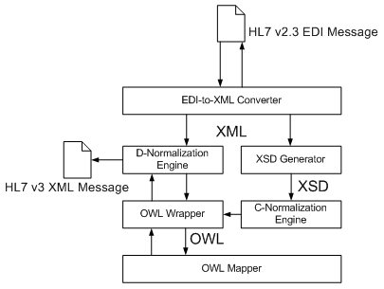
Figure 1. The Overall System Architecture
In this paper, we address this problem and show how HL7 Version 3 messages can be semantically mediated with HL7 Version 2 messages. The overall system architecture, as shown in Figure 1, involves the following components:
- OWL Ontology Mapping Tool (OWLmt): The main component of the architecture is the OWL mapping tool. The mappings created through this tool are used for transforming the instances of the source ontology into target ontology instances. Given that in a realistic healthcare setting today, the exchanged message instances EDI or XML, not messages conforming to an ontology, the source messages in EDI format need to be converted into OWL message instances and the target ontology message instances need to be converted to XML. Furthermore, there is a need for automatic generation of OWL Schemas from XML Schema Definitions (XSDs). The rest of the components in the system are used for these purposes.
- EDI to XML Converter: Since HL7 version 2 mostly uses EDI messages, these messages need to be converted to XML first. The open-source programming library from HL7, namely, HAPI (HL7 application programming interface) is used in transforming the EDI messages into their XML representations.
- XML Schema Generator: For generating the XML Schemas of the resultant messages, Castor's XMLInstance2Schema tool [2] is used.
- C-Normalization engine: Conceptual Normalization (C-Normalization) engine of the Harmonise project [5] is used to parse the XML Schema, and create the corresponding RDFS schema [17].
- OWL Wrapper: Since OWLmt uses OWL Schemas instead of RDFS schemas, an OWL wrapper is developed using Jena API [11] to create OWL schemas out of RDFS files after the C-Normalization step.
- D-Normalization engine: Data Normalization (D-Normalisation) Engine transforms the data instances from XML to OWL or OWL to XML. In this step, the output of the C-Normalization step, “Normalization Map”, is given as an input to describe how each component in XSD can be transformed into a component in RDFS and vice-versa.
In the following sections, all of these components are described in detail.

2.1. OWL Mapping Tool: OWLmt
Ontology Mapping is the process where two ontologies with an overlapping content are related at the conceptual level, and the source ontology instances are automatically transformed into the target ontology instances according to these relations. We have developed an OWL mapping tool, called OWLmt, to handle ontology mediation by mapping the OWL ontologies in different structure but with an overlapping content one into other. The architecture of the system, as shown in Figure 2, allows mapping patterns to be specified through a GUI tool based on a Mapping Schema. The Mapping Schema, as shown in Figure 3, is also defined in OWL. The mapping engine uses the mapping patterns specified through the GUI to automatically transform source ontology instances into target ontology instances.
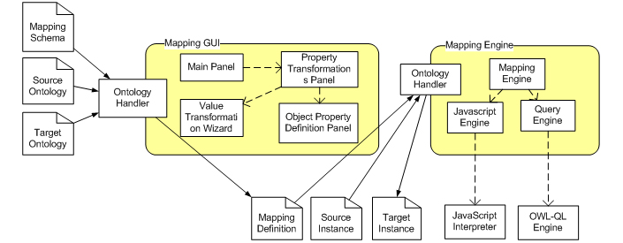
Figure 2. The Architecture of OWLmt
Mapping patterns basically involve the following:
- Matching the source ontology classes to target ontology classes: In order to represent the matching between the classes of source and target ontologies, we have defined four mapping patterns: EquivalentTo, SimilarTo, IntersectionOf and UnionOf. Two identical classes are mapped through EquivalentTo pattern. SimilarTo pattern implies that the involved classes have overlapping content. How these two classes are related is determined through further mapping of their datatype properties and object properties. The IntersectionOf pattern creates the corresponding instances of the target class as the intersection of the declared class instances. Similarly, the UnionOf pattern takes the union of the source classes’ instances to create the corresponding instances of the target class.
Furthermore, a class in a source ontology can be a more general (super class) of a class in the target ontology. In this case, which instances of the source ontology makes up the instances of the target ontology is defined through KIF conditions to be executed by the mapping engine. When a source ontology class is a more specific (sub class) of a target ontology class, all the instances of the source ontology qualify as the instances of the target ontology.
- Matching the source ontology Object Properties to target ontology Object Properties: In addition to matching a single object property in the source ontology with a single object property in the target ontology, in some cases, more than one object properties in the source ontology can be matched with one or more object properties in the target ontology. Therefore, OWLmt allows defining “ObjectPropertyTransform” pattern which represents the path of classes connected with object properties. Paths are defined as triples in KIF [13] format and executed through the OWL-QL [16] engine. Through such patterns, the OWLmt constructs the specified paths among the instances of the target ontology in the execution step based on the paths defined among the instances of the source ontology.
- Matching source ontology Data Properties to target ontology Data Properties: Specifying the “DatatypePropertyTransform” helps to transform datatype properties of an instance in the source ontology to corresponding target ontology instance datatype properties. Since the datatype properties may be structurally different in source and target ontologies, more complex transformation operations may be necessary than copying the data in source instance to the target instance. XPath specification [18] defines a set of basic operators and functions which are used by the OWLmt such as “concat”, “split”, “substring”, “abs”, and “floor”. In some cases, there is a further need for a programmatic approach to specify complex functions. For example, the use of conditional branches (e.g. if-then-else, switch-case) or iterations (e.g while, for-next) may be necessary in specifying the transformation functions. Therefore, we have added JavaScript support to OWLmt. By specifying the JavaScript to be used in the “DatatypePropertyTransform” pattern, the complex functions can also be applied to the data as well as the basic functions and the operators.
2.1.1 OWLmt Mapping Schema
The mapping patterns used in the OWLmt are defined through an OWL ontology called “Mapping Schema”. Each mapping pattern is an owl:class in the “Mapping Schema” as shown in Figure 3. The additional information needed in the execution of the patterns such as “inputPath” and “outputPath” for ObjectProperty Transform pattern are defined as properties of this class. The “inputPath” and “outputPath” datatype properties hold the query strings in the KIF format which are used in the execution to query the source ontology instances in order to build the target instances.
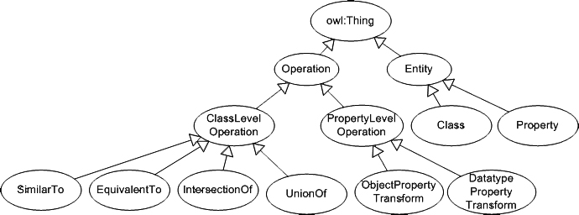
Figure 3. OWL Mapping Schema
2.1.2 OWLmt GUI
OWLmt GUI, as shown in Figure 4, allows the user to define the mapping patterns. It consists of five components: Ontology Handler, Main Panel, Property Transformations Panel, Value Transformation Wizard and Object Property Definition Panel. The Ontology Handler is used in parsing and serializing the ontology documents. The class mapping patterns are defined in the main panel. The property mapping patterns are defined in the property transformation panel. This panel lets the user to create new property mapping patterns such as the “ObjectPropertyTransform” and “DatatypePropertyTransform”. The value transformation wizard is used to configure a “DatatypePropertyTransform” pattern. By using this wizard, the functions used in the value transformation of the datatype properties can be specified.
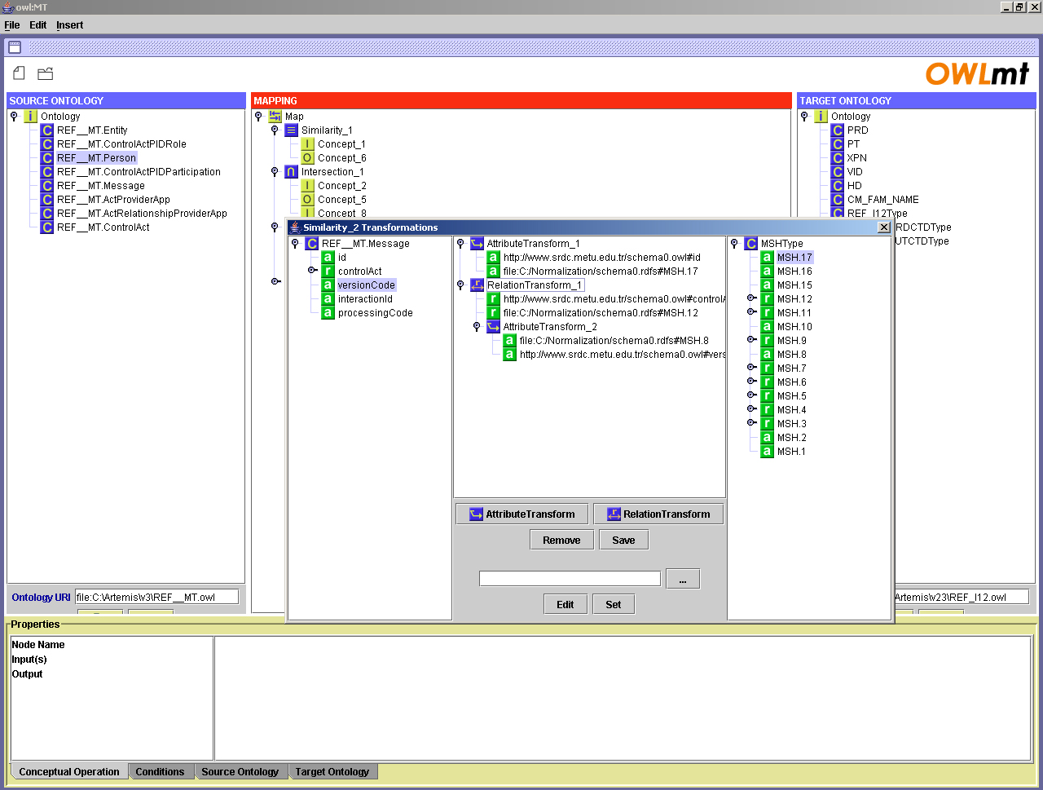
Figure 4. OWLmt GUI
2.1.3 OWLmt Engine
The mapping engine is responsible for creating the target ontology instances using the mapping patterns and the instances of the source ontology. It uses OWL Query Language (OWL-QL) to retrieve required data from the source ontology instances. OWL-QL is a joint US/EU initiative to develop a query language for OWL [16]. While executing the class and property mapping patterns, the query strings defined through the mapping GUI are send to the OWL-QL engine with the URL of the source ontology instances. The query engine executes the query strings and returns the query results.
The OWL-QL engine uses the JTP reasoning engine [12], an object-oriented modular reasoning system. The system consists of the modules called reasoners classified into “asking reasoners” and “telling reasoners” according to their functionality. The “asking reasoners” process queries and return proofs for the answers while the “telling reasoners” process assertions and proofs and draw conclusions. The modularity of the system enables it to be extended by adding new reasoners or customizing existing ones.
The use of the OWL-QL enables OWLmt to have reasoning capabilities. When querying the source ontology instances or while executing the KIF patterns, OWL-QL reasons over the explicitly stated facts to infer new information. As an example, consider two instances, I1 and I2, which are the members of the classes C1 and C2 respectively. If these two instances are related with the "owl:sameAs" construct, one of them should be in the extension of the intersection class, say C3, of the classes C1 and C2. Hence, the IntersectionOf pattern transforms the instance I1 and I2 to the instance I3 which is a member of C3 in the target ontology. However, assume that there is no direct "owl:sameAs" construct but there is a functional property which implies that these two instances are the same. The reasoning engine can infer from the definition of the "owl:FunctionalProperty" by using the rule;
- (rdf:type ?prop owl:FunctionalProperty) (?prop ?instance ?I1) (?prop ?instance ?I2) →(owl:sameAs ?I1 ?I2)
that the instances I1 and I2 are the same instance resulting in the instance I3 to be in the target ontology.
After executing the class mapping patterns, the mapping engine executes the property mapping patterns. Similar to the class mapping patterns, OWL-QL queries are used to locate the data. In order to perform value transformations, the mapping engine uses the JavaScripts in the “DatatypePropertyTransform” pattern. To execute the JavaScripts, an interpreter is used. The engine prepares the JavaScript by providing the values for the input parameters and sends it to the interpreter. The interpreter returns the result, which is then inserted as the value of the datatype property in the target ontology instance.

2.2. EDI to XML Conversion in HL7
There are several commercial and open-source programming libraries that implement the HL7 standards. In our architecture, HAPI [4] (HL7 Application Programming Interface) Assembler/Disassembler Tool is used to transform the EDI messages into their XML representations. HAPI provides open source libraries for parsing and manipulating both EDI and XML messages that are HL7 conformant. Furthermore the library enables message validation (e.g. enforcement of HL7 data type rules for the values in the messages).

2.3. Normalization Tool
As previously mentioned, currently the healthcare application messages are usually in XML or EDI format (which can be converted to XML). Hence there is a need for automatic bidirectional transformation of XML message instances to OWL message instances as well as automatic generation of OWL Schemas from XML Schema Definitions (XSDs). Such a transformation, called Normalization, has been realized within the scope of the Harmonise project [5].
The “Normalization Engine” of the Harmonise project is used in generating RDFS schemas from local XSD schemas. This step is called Conceptual Normalization (C-Normalization) phase where the C-Normalization engine parses the XML Schema, and using a set of predefined “Normalization Heuristics”, creates the corresponding RDFS schema components for each XML Schema component automatically. Normalization Heuristics define how specific XML Schema construct (e.g. complex type definition) can be projected onto a RDFS construct (entity or set of related entities) [5]. This process produces a “Normalization Map” which defines the associations between the XML Schema and the re-engineered RDFS model.
The second step in the Normalization process is the Data Normalization Process (D-Normalization) which is used for transforming the data instances from XML to OWL or OWL to XML. In this step, the output of the C-Normalization step, “Normalization Map”, is used to guide transforming each component in XSD to a component in RDFS or vice-versa.
In Artemis architecture, we have used the Harmonise Normalization Engine. However since we need OWL Schemas instead of RDFS schemas, we developed an OWL wrapper using Jena API to create OWL schemas from the RDFS files after the C-Normalization step. Additionally in the D-Normalization step, through the same wrapper, the generated RDF instances are further translated in to OWL instances or vice versa as depicted in Figure 5.
Note that in Harmonise C-Normalization step, the enumeration of property values or basic data types defined in XML Schemas cannot be preserved. To handle this, the OWL Wrapper developed carries the enumeration of property values and basic data types to the OWL Schema. The enumerated classes are represented using <owl:oneOf rdf:parseType="Collection"> construct in case of enumerated classes, and using <owl:oneOf> <rdf:List> construct in case of enumerated datatypes. The data types are respresented by referring to XML Schema datatypes using RDF datatyping scheme.
XML Schema
Normalization
Heuristics
Harmonise
C-Normalization Engine
RDFS
Normalization Map
OWLS
OWL
Wrapper
OWL
Mapper
OWL Instance
OWL Instance
OWL
Wrapper
RDF Instance
Harmonise
D-Normalization
Engine
XML Instance
Jena
Data types and enumerations
Figure 5. Normalization process for the bidirectional transformation of XML instances to OWL instances

3. Conclusions
As identified by CEN/ISSS eHealth Standardisation Focus Group [9], one of the most challenging problems in healthcare domain today is providing interoperability among healthcare information systems. In order to tackle this problem, we propose an engineering approach to semantic interoperability within the scope of the Artemis project. For this purpose, the existing applications are wrapped as Web services and the messages they exchange are then mediated through an ontology mapping tool developed, namely, OWLmt. One of the major contributions of the OWLmt is the use of OWL-QL engine which enables the mapping tool to reason over the source ontology instances while generating the target ontology instances according to the graphically defined mapping patterns.
Although the platform proposed is generic enough to mediate between any incompatible healthcare standards that are currently in use in the healthcare domain, we have chosen to mediate between HL7 Version 2 and HL7 Version 3 messages to demonstrate the functionalities of the proposed platform. Since neither version 2, nor version 3 messages are ontology instances, their message structures, EDI and XML respectively, are normalized to OWL before OWL mapping process. Additional tools exploited for this purpose have also been elaborated in the paper.

References
[1] Artemis – A Semantic Web Service-based P2P Infrastructure for the Interoperability of Medical Information Systems, http://www.srdc.metu.edu.tr/webpage/projects/artemis/ .
[2] Castor's XMLInstance2Schema tool, http://castor.exolab.org/.
[3] ENV 13606:2000 “Electronic Healthcare Record Communication”, http://www.centc251.org/TCMeet/doclist/TCdoc00/N00-048.pdf.
[4] HL7 Application Programming Interface, http://hl7api.sourceforge.net
[5] Harmonise, IST–2000-29329, Tourism Harmonisation Network, Deliverable 3.2 Semantic mapping and Reconciliation Engine subsystems.
[6] Health Level 7, http://www.hl7.org.
[7] HL7 Reference Information Model, http://www.hl7.org/library/data-model/RIM/modelpage_mem.htm.
[8] HL7 Version 3 Specification, http://www.hl7.org/library/standards_non1.htm#HL7 Version 3.
[9] Report from the CEN/ISSS eHealth Standardization Focus Group “Current and future standardization issues in the e-Health domain: Achieving interoperability”, Part One: Main text, Draft V4.1, 2004-08-16.
[10] ISO/TS Health Informatics – Requirements for an electronic health record architecture, Technical Specification, International Organization for Standardization (ISO), Geneva, Switzerland, 2004.
[11] Jena Framework, http://jena.sourceforge.net/ .
[12] Java Theorem Prover, http://www.ksl.stanford.edu/software/JTP/ .
[13] Knowledge Interchange Format, http://logic.stanford.edu/kif/kif.html .
[14] OpenEHR Foundation, http://www.openehr.org/ .
[15] Web Ontology Language, http://www.w3.org/TR/owl-features/.
[16] OWL Query Language, http://ksl.stanford.edu/projects/owl-ql/ .
[17] Resource Description Framework Schema, http://www.w3.org/TR/rdf-schema/ .
[18] XML Path Language, http://www.w3.org/TR/xpath .

This work is supported by the European Commission through IST-1-002103-STP Artemis Project and in part by the Scientific and Technical Research Council of Turkey (TŰBİTAK), Project No: EEEAG 104E013

