Design and Implementation of the eInvoice Interoperability Profile of the Revenue Administration of Turkey

Asuman DOĞAÇ¹, Arif YILDIRIM², Yıldıray KABAK³, Gökçe Laleci ERTÜRKMEN³, Çağdaş ÖCALAN³ and Muarrem BİLEN²
¹ Dept. of Computer Engineering, Middle East Technical University, İnönü Bulvari, Ankara, 06531, Turkey
Tel: +90 312 2405598, Fax: + 90 312 2101259, asuman@metu.edu.tr
² Revenue Administration, Yeni Ziraat Mahallesi Etlik Cad. No: 16, Dışkapı, Ankara, 06110, Turkey
Tel: +90 312 342 2741, Fax: + 90 3123422741, AYILDIRIM@gelirler.gov.tr
³Software Research, Development and Consultancy Ltd., METU-KOSGEB Tekmer, Ankara, 06531, Turkey
Tel: +90 312 2102076, Fax: + 90 312 2105572, yildiray@srdc.com.tr
Abstract: Turkey’s eInvoice Interoperability Profile is being realized by the Revenue Administration (Gelir İdaresi Başkanlığı, GIB). The GIB eInvoice Interoperability Profile addresses all the layers in the interoperability stack, namely, the content of the eInvoice documents, the transport and communication interoperability and the business process layer interoperability. For the Document Content Layer, the UBL 2.0 Invoice documents are localized to Turkey by using the “conformant” customization guidelines of UBL. The Business Process Layer, involves the Seller’s Access Point, Buyer’s Access Point and the GIB as a hub since the transfer of invoices is realized through Access Points and GIB receives a copy of the every invoice exchanged. The GIB eInvoice infrastructure is Web service based and comprehensive security and privacy measures are introduced based on open standards including SSL, WS-Security and WS-Trust. For testing the conformance and interoperability of applications to GIB’s interoperability profile, a general purpose test framework is customized. TestBATN Framework is designed to allow dynamic, configurable and fully automated execution of conformance and interoperability test scenarios.

Introduction
Interoperability is the ability of two or more systems or components to exchange information and to use the information that has been exchanged [1]. More specifically, interoperability is said to exist between two applications when one application can accept data (including data in the form of a service request) from the other and perform the task in an appropriate and satisfactory manner (as judged by the user of the receiving system) without the need for extra operator intervention [2].
Public authorities as well as businesses must agree on a common set of standards and protocols for communicating in order to have an interoperable framework. Without a common set of interoperability profiles, public authorities could end up establishing propriety protocols for exchanging digital business documents, thus requiring each public authority to support several different protocols to communicate with other public authorities and companies.
The “interoperability profiling” in the Information Technology means fixing the roles, the business processes and the interactions in a given use-case scenario and then determining the standards to be used at each layer of the interoperability stack, possibly by further restricting them. The interoperability stack involves the document content layer, the transport and the communication layer and the business process layer. The basic e-business requirement of authentication, confidentiality, integrity and non-repudiation must also be handled by the profile.
In this paper, we describe the eInvoice Interoperability Profile of the Revenue Administration (Gelir İdaresi Başkanlığı, GIB) of Turkey. GIB [3] is in charge of revenue management in Turkey including implementing the state revenue policy; ensuring to collect the governmental claims; measuring the costs of all exceptions, exemption and discounts in the tax laws or other fiscal laws and carrying out tax inspection and audit at the direction of main policies and strategies determined by the Ministry of Finance.
In order increase its efficiency and effectiveness towards accomplishing its tasks, the Revenue Administration has realized an eInvoice Interoperability Profile. In this first phase of the implementation, only the invoicing process is considered and the other procurement processes such as ordering and payment are left as future work. Hence the matching of the Invoice to other electronic documents like order is not considered.

GIB eInvoice Interoperability Profile
The GIB eInvoice Interoperability Profile addresses all the layers in the interoperability stack, namely, the document layer, transport and communication layer and the business process layer. Furthermore, mechanisms are provided for authentication, confidentiality, integrity and non-repudiation. An important aspect of the profile developed is its tool support for interoperability testing. Interoperability testing involves checking whether the applications conform to the profile defined so that they can interoperate with other conformant applications. For the GIB eInvoice Interoperability Profile, a general purpose testing tool, namely, TestBATN is specialized to test the conformance of applications to the profile.

The GIB eInvoice Interoperability Profile: Document Content Layer
For the GIB eInvoice Interoperability Profile Document Content Layer, the UBL 2.0 [4] Invoice documents are localized to Turkey through the work of OASIS UBL Turkish Localization Subcommittee [5] by using the “conformant” customization guidelines of UBL. The Universal Business Language (UBL) in an OASIS initiative and develops a set of standard XML business document definitions. Currently, the approved version of UBL is 2.0 and there are thirty one XML schemas for common business documents like “order” and “invoice”. In addition to the document definitions, UBL 2.0 provides a library of XML schemas (XSDs) for reusable common data components like “Address”, “Item", and “Payment" from which the documents are constructed.
The UBL documents can be customized to specific needs in two ways: the “conformant” customization which is used in Turkey, allows the XML instances in the customized implementation to also conform to the original standard UBL 2.0 schemas hence providing interoperability with other conformant schemas. The following changes are made to UBL 2.0 eInvoice documents while localizing them to the GIB Profile [5]:
- The optional “UBLExtensions” element is used to include non-UBL data elements specific to the intended use in Turkey. For example, the XSL files that are used to visualize the Invoice documents, are embedded in the “UBLExtensions” element. Indeed, the “UBLExtensions” element, which appears as the first child of all UBL 2.0 documents, allows for conformant customizations by restricting the use of non-UBL elements inside these tags.
- The optional information entities in the original UBL 2.0 invoice documents that are not necessary for the GIB Profile are removed. For example, “TaxPointDate” information entity is removed from the Invoice document, since in Turkey the “IssueDate” is used to indicate the point at which the tax becomes applicable. Clearly, removing the optional elements does not violate the conformance to the original UBL schema.
- There are additional constraints on the value space of the information entities in the GIB Profile. For example, a constraint is introduced to check whether the sum of “TaxAmount” items of the “TaxSubtotal” elements in a “TaxTotal” entity is equal to the “TaxAmount” item of the respective “TaxTotal” entity. Such requirements are reflected in the UBL schemas through Schematron rules.
- Finally, the customization of the code lists is realized. The code lists are used to convey the meaning of the values in the data elements. In UBL 2.0, only three code lists are enumerated in the schemas: (1) The CurrencyCodeContentType for internationally standardized currency codes, (2) The BinaryObjectMimeCodeContentType for MIME encoding identifiers and (3) The UnitCodeContentType for unit codes. The other code lists used in UBL are not enumerated in the schema expressions. Instead, UBL uses a common base type called CodeType, which is an extension of “xsd:normalizedString” for all elements expressing values from the code lists. The UBL 2.0 package includes files for every code list. These files are separate from the provided XSD schemas and they are in a standard format. For the GIB Profile, these files are generated for the codes used in Turkey. For example, a value set for “TaxTypeCode” basic business information entity is created. Some example values for this value set are: Income Tax, Value Added Tax (VAT), and Stamp Tax.
- Validation of the eInvoice, Turkey: UBL 2.0 recommends a two-phase validation technique since the specification of the default values directly in the schemas makes it difficult to modify the code lists to meet customization requirements. In the GIB implementation, the two-phase validation technique is used: in the first phase, an incoming invoice document is validated against UBL 2.0 GIB eInvoice XSD schemas. If the instance passes the first phase, in the second phase it is checked against the rules, which specify GIB business constraints on the values of the elements in the instance. These rules are specified through Schematron language. If the instance passes both of the phases successfully, it is delivered to the processing business application.

The GIB eInvoice Interoperability Profile: Business Process Layer
The following decisions and observations affected the resultant GIB eInvoice Interoperability Profile Business Process Layer:
- The first decision was to use “Access Points” to transfer the invoice between the seller and the buyer. The banks, GIB and the big companies can take the role of an “Access Point” if they wish to.
- The second decision was to use GIB as a hub for transferring the invoices. GIB receives a copy of all the invoices in Turkey and checks them for validation of tax values, tax accounting and payment. Since they already receive a copy of every invoice, in the infrastructure, they play the role of a “hub” for the routing of the invoices.
Therefore, in addition to the “Seller” and “Buyer” main actors, as shown in Figure 1, the following additional actors are defined for the use-case scenario: “Seller’s Access Point”, “Buyer’s Access Point” and the GIB (the Revenue Administration).

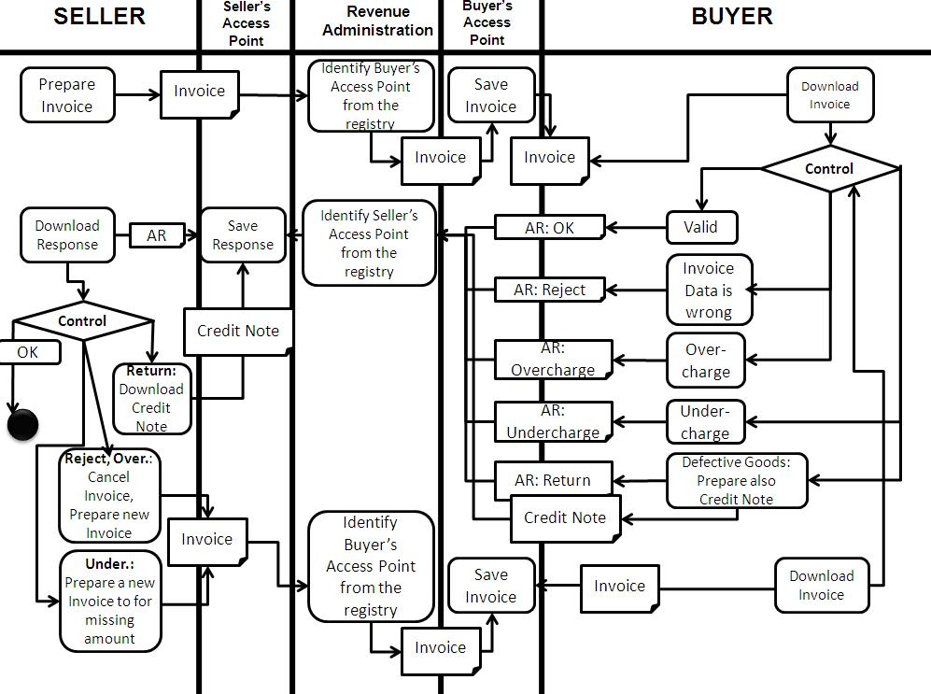
Figure 1 An overview of the GIB eInvioce Interoperability Profile Business Process Layer
In implementing the business process layer, a service oriented infrastructure is designed to handle the following two different kinds of requirements: the big companies wish to send the invoices generated from their ERP systems either directly (if they themselves are Access Points) or through the access points involved. For this case, the companies need to maintain registries to discover the Web services of the corresponding Access Points. However, small and medium size enterprises (SMEs) often do not have the infrastructure to send a digital invoice directly; they may prefer to upload and download their invoices manually from their Access Points.
As shown in Figure 1, the GIB eInvioce Interoperability Profile Business Process is as follows:
- The seller sends the invoice to its Access Point, say Access Point A, either manually uploads or sends directly by using the Access Point’s related Web service.
- Access Point A transfers the invoice to GIB using GIB’s related Web service.
- GIB registers the invoice and through the UDDI registry it maintains, finds out about the Buyer’s Access Point’s (say Access Point B) Web service end point and invokes the service to transfer the invoice to Access Point B. Each entity in Turkey has a unique tax identifier (Vergi Kimlik Numarası, VKN) and this VKN identifier is used in order to ensure the correct identification of the involved Access Point to invoke its relevant Web service.
- The buyer downloads (or receives it through its Web service) the invoice from its Access Point
- The buyer and validates invoice’s content:
  - If the invoice is correct, the buyer sends an “Application Response: OK” to its Access Point B.
  - If the invoice contains incorrect information the buyer rejects the invoice with “Application Response: Reject”
  - If the invoice is overcharge, the buyer sends an “Application Response: Overcharge” to its Access Point B
  - If the invoice is undercharge, the buyer sends an “Application Response: Undercharge” to its Access Point B
  - If the invoice is correct but some of the received goods are defective, the seller prepares a Credit Note (İade Faturası)
- Access Point B using GIB’s related Web service, returns the response to GIB.
- GIB, using its UDDI registry, finds the end point of the Web service of Access Point A (Seller’s Access Point), and informs the Access Point of the response.
- The seller downloads (or receives it through its Web service) the response from its Access Point and validates its content
  - If the response is “Application Response: OK”, that is, the invoice is accepted, the payment process starts
  - If the response is “Application Response: Reject”, the invoice is cancelled and a new invoice is prepared and the process starts from the beginning
  - If the response is “Application Response: Overcharge”, the invoice is cancelled and a new invoice is prepared and the process starts from the beginning
  - If the response is “Application Response: Undercharge”, a new invoice is prepared to make up the difference and the process starts from the beginning for this new invoice
  - If the response is a “Credit Note”, the “Credit Note” process starts

The GIB eInvoice Interoperability Profile: Transport and Communication Layer
The communication layer in the interoperability stack addresses the transport protocol such as HTTP and the packaging protocol such as “Simple Object Access Protocol (SOAP)” [6]. The GIB eInvoice infrastructure is Web service based. The information that an application must have available in order to invoke a Web service is defined by two universally accepted standards: Web Service Description Language (WSDL) [7] and Simple Object Access Protocol (SOAP) [6]. The WSDL of a Web service defines its interface and establishes its public contract with the outside world. In other words, WSDL standardizes how to invoke a service. It provides information on the data being exchanged, the sequence of messages for an operation, the location of the service and the description of bindings (e. g. SOAP).
The GIB Web service profile uses HTTP for transport and SOAP for packaging with the following WS-* standards:
- “WS-Security Username-Token Profile” is used for authentication. Through WS-Security [8] how to attach signatures and encryption headers to SOAP messages and how to attach security tokens, including binary security tokens such as X.509 [9] certificates are described.
- WS-Trust [10] for sharing the symmetric keys. WS-Trust provides extensions to WS-Security for the issuing, renewing, and validating the security tokens, as well as with ways to establish, assess the presence of, and broker trust relationships between participants in a secure message exchange.
- “WS-Reliable Messaging” [11] is used for reliability of the messages. WS-ReliableMessaging describes a protocol that allows SOAP messages to be delivered reliably between distributed applications in the presence of software component, system, or network failures.
For the discovery of the services, a UDDI registry [12] is maintained by the GIB. The UDDI registry provides the Web service endpoints which give information about the web service itself as well as information on how to access and use the Web service. The Access Points must register their information as well as their Web services to this registry in order for GIB to find and use these services to transfer the invoices among the Access Points.

The GIB eInvoice Interoperability Profile: the authentication, confidentiality, integrity and non-repudiation of messages
The security architecture of the GIB eInvoice Profile is given in Figure 2. A VPN (Virtual Private Network, VPN) is established to restrict access from outside the network. Through VPN, communications are secured through the public Internet and it does not need explicit security features, such as authentication or content encryption. GIB’s VPN is used to separate the traffic of its user community over the Internet with strong security features. SSL (Secure Sockets Layer) is used to provide confidentiality of communications over the Internet. SSL encrypts the datagrams of the Transport Layer protocol for an end-to-end connection across the network. WS-Security UsernameToken Profile 1.0 is used for authentication and non-repudiation.

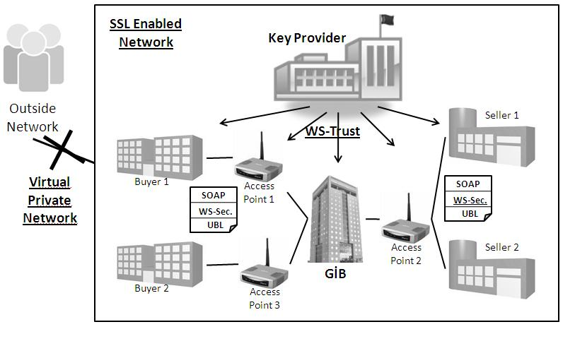
Figure 2 Security Architecture in the GIB eInvoice Profile

In Turkey, GIB is authorized to see the content of all invoices, however the Access Points should not see all the invoice details. In providing the privacy of the invoices, the parts of the invoice documents that are confidential to GIB, are encrypted with a key known to the involved parties, that is, the buyer, the seller and GIB.

Testing the conformance and interoperability of applications to GIB’s Interoperability Profile
Only through testing, correct information exchange among involved applications can be guaranteed and products can be certified. For testing the conformance and interoperability of applications to GIB’s interoperability profile, a general purpose test framework is customized. TestBATN Framework [13] is designed to allow dynamic, configurable and fully automated execution of conformance and interoperability test scenarios. Conformance to a standard is a system’s ability to satisfy all the requirements expressed within the standard. Conformance Testing is realized through a collection of test cases each evaluating whether the requirements are satisfied. On the other hand, Interoperability Testing involves not only the conformance evaluation for each role, but also testing their ability to function collaboratively to achieve a set of requirements.
The main components of the system are as follows:
- Messaging Interface: A Messaging Interface is used to test communication layer interoperability. In order to test the application’s conformance to GIB’s Interoperability Profile, SOAP Adaptor is used. This adaptor has the ability to fragment a message into its parts such as SOAP Header, SOAP Body and SOAP Attachments or defragment the parts into a message. The fragments are assigned to variables so that further test assertions can be specified and tested. Both the Transport and the Packaging adaptors are configurable, that is, it is possible to apply them selective restrictions.
- Evaluation Interface: Evaluation interfaces are used at the document interoperability layer for syntactic validation and semantic verification of GIB eInvoice documents. The XML Schema Validators, XPATH verifiers and Schematrons are used for this purpose.
- Test Engine: Test engine drives the test scenario defined through the TestBATN Test Description Language by communicating with the SUT (System Under Test) Administrators, Evaluation Interfaces and Messaging interfaces as needed. It acts like an interpreter and executes test steps defined in the test case XML instance according to the flow constructs. During this interpretation, the test engine maintains an environment which consists of variables, expressions and placeholders.
- Test Design GUI and Test Management GUI: To facilitate the test design and monitoring Web based graphical tools are provided to the users.
- Test Framework Database stores all the re-usable test material including the test descriptions and the adaptors.

Conclusions
The vision of e-Government in Turkey places e-Government at the core of public management modernization and reform, where technology is used as a strategic tool to modernize structures, processes, the regulatory framework to provide better government and ultimately increased public value. To achieve this vision, the public administrations must ensure that their information is accessible to all and hence must avoid proprietary solutions. GIB followed this trend to develop eInvoice interoperability profile which is based on open XML based standards. It is believed that GIB’s Interoperability Profile will be a driver for further digitization in Turkey which is a key parameter for increasing competitiveness.
GIB’s Interoperability Profile addresses all the layers at the interoperability stack. At the document content layer, an important document content standard from OASIS, namely, UBL 2.0 is localized to Turkey [5]. UBL has a high degree of penetration in the eGovernment applications in Europe. The first use of UBL Invoice in government applications is realized in Denmark through the “Offentlig Information Online UBL (OIOUBL)" [14] Project and has been mandated by law for all public-sector businesses. Also in Sweden, the National Financial Management Authority recommended UBL Invoice customized to Sweden, namely, Svefaktura for all government use [15]. Following the success of Danish and Swedish examples, representatives from Denmark, Norway, Sweden, UK, Finland and Iceland have created a Northern European Subset (NES) [16] for UBL to ensure interoperability among these countries. Finally, a large scale integration project is being carried out in EU to set up a pan-European pilot solution that facilitates EU-wide interoperable public eProcurement based on UBL 2.0.
At the transport and communication layer, a Web service based architecture is designed. Web services are application functions that can be invoked by software over the Internet. Web services have two big advantages: they are supported by every major corporation and they have a flexible core language which is XML. A Web service is, in fact, a layer for access to a service, which is implemented by other kinds of middleware. Access consists of request handling (a listener) and a facade that exposes the operations supported by the business logic. The logic is implemented by a traditional middleware platform. Behind the facade of a Web service, the XML request message is converted to a middleware request and the results are converted back to XML format.
At the business process layer, the well-defined interactions among the actors involved provides for the interoperability at this layer.
Any interoperability profile must address the basic e-business requirement of authentication, confidentiality, integrity and non-repudiation and the GIB’s Interoperability Profile contains comprehensive security and privacy measures based on open standards including SSL, WS-Security and WS-Trust.
Finally, for testing the conformance and interoperability of applications to GIB’s interoperability profile, a general purpose test framework is customized.

References
[1] IEEE Dictionary. Institute of Electrical and Electronics Engineers. IEEE Standard Computer Dictionary: A Compilation of IEEE Standard Computer Glossaries. New York, NY: 1990.
[2] Brown and Reynolds. Strategy for production and maintenance of standards for interoperability within and between service departments and other healthcare domains. CEN/TC 251 Health Informatics, CEN/TC 251/N00-047.
[3] Gelir İdaresi Başkanlığı (GIB), Türkiye, http://www.gib.gov.tr/index.php?id=466
[4] Universal Business Language (UBL) 2.0, http://www.oasis-open.org/committees/tc_home.php? wg_abbrev=ubl
[5] OASIS UBL Turkish Localization Subcommittee, http://www.oasis-open.org/committees/sc_home. php?wg_abbrev=ubl-trlsc
[6] Simple Object Access Protocol (SOAP), http://www.w3.org/TR/soap/
[7] Web Services Description Language, http://www.w3.org/TR/wsdl
[8] OASIS Web Services Security (WSS) TC, http://www.oasis-open.org/committees/tc_home.php? wg_abbrev=wss
[9] ITU-T Recommendation X.509: Information Technology - Open Systems Interconnection - The Directory: Authentication Framework, 08/05.
[10] OASIS Web services Trust, http://docs.oasis-open.org/ws-sx/ws-trust/200512/ws-trust-1.3-os.html
[11] OASIS Web Services Reliable Messaging (WSRM), http://www.oasis-open.org/committees/tc_home.php? wg_abbrev=wsrm
[12] OASIS UDDI Specification TC, http://www.oasis-open.org/committees/tc_home.php?wg_abbrev=uddi-spec
[13] Namlı T., Aluc G., Dogac A., An Interoperability Test Framework for HL7 based Systems, Submitted for publication, [Online], http://www.srdc.metu.edu.tr/webpage/publications/2008/_TestBATN-Framework.pdf
[14] Offentlig Information Online UBL (OIOUBL), http://www.oioubl.info/classes/en/index.html
[15] Svefaktura. Swedish Invoice. http://www.svefaktura.se/SFTI_Basic_Invoice20051130_EN/
SFTI\%20Basic\%2%0Invoice_1.0/index.html.
[16] NES. UBL Northern European Subset. http://www.nesubl.eu/
[17] PEPPOL pilot (Pan-European Public eProcurement On-Line), http://www.peppol.eu/

