Towards a Global Interoperability Test Bed for eBusiness Systems
Nenad IVEZIC¹, Hyunbo CHO², Jungyub WOO¹, Junho SHIN¹, Jaewook KIM¹, Mohammad ABIDI³, Asuman DOGAC⁴, Tuncay NAMLI⁵, Christine LEGNER⁶, Francois FISCHER⁷

¹NIST, 100 Bureau Drive, Gaithersburg, MD, 20899, USA
Tel: +001 301 975-3536, Fax: + 001 301 975 4482,
Email: {nivezic|jungyub.woo|shinjh|jaewook@nist.gov}
²Department of Industrial and Management Engineering, Pohang University of Science and Technology, San 31, Hyoja, Pohang 790-784, Korea
Tel: +82 54 279-2204, Fax: +82 54 279-2870, Email: {hcho@postech.ac.kr}
³Automotive Industry Action Group, 26200 Lahser Rd., St. 200, Southfield, MI 48034, USA
Tel: +001 248 358-3570, Fax: +001 248 358-3570, Email: {mabidi@aiag.org}
⁴Dept. of Computer Engineering, Middle East Technical University, İnönü Bulvari,
Ankara, 06531, Turkey
Tel: +90 312 2405598, Fax: + 90 312 2101259, Email: asuman@srdc.metu.edu.tr
⁵Software Research, Development and Consultancy Ltd., METU-KOSGEB Tekmer,
Ankara, 06531, Turkey
Tel: +90 312 2102076, Fax: + 90 312 2105572, Email: tuncay@srdc.com.tr
⁶Chair of Enterprise Systems and Electronic Business, Campus Burg, Remise, 2. Obergeschoss, Germany, Tel: +49 (0)6723/991-250, Fax: +49 (0)6723/991-255, Email: christine.legner@ebs.edu
⁷ETSI, 650 route des Lucioles, 06921 Sophia-Antipolis Cedex, France
Tel: +33492944330, Email: francois.fischer@etsi.org
Abstract: We describe an initial effort to create a comprehensive and coherent framework for feasibility analysis of the Global Interoperability Test Bed for eBusiness systems. Requirements from an initial set of three industrial use cases are driving the feasibility analysis. Both functional and non-functional requirements are analyzed leading to an assessment of gaps between the requirements and existing testing capabilities. The requirements and gap analysis, then, will drive preliminary risk analysis for the GTIB.

Introduction
This paper presents preliminary results of an on-going feasibility analysis of a Global Interoperability Test Bed (GITB) for eBusiness systems testing. The work on GITB is motivated by the increasing need to support testing of eBusiness systems across different world regions while positively affecting development cost, capability, and compatibility of future testing facilities as well as trust among the collaborating organizations.
The on-going feasibility analysis is the initial of the three development phases and will be followed by the architecting phase and the prototyping and demonstration phase. During the initial phase, the requirements from three industrial use cases are gathered at multiple levels (i.e., business, functional, and non-functional requirements) and analyzed using a proposed shared conceptualization for eBusiness test beds. The existing eBusiness testing capabilities are, then, compared to the requirements, leading to an assessment of gaps between the requirements and the existing testing capabilities. Finally, we will perform preliminary risk analysis in the light of the requirements and the gap analysis.

Objectives
The objective of this work is to establish a conceptual framework and perform initial feasibility analysis for the Global Interoperability Test Bed for eBusines systems.

Methodology

Process Overview
Initially, we analyze expressions of testing needs for eBusiness systems. At this stage we typically deal with expressions of business requirements, engineering functional and non-functional requirements, and operating environment requirements.
Business-level requirements specify the subject of testing (i.e., What type of concern to test for?). Engineering-level requirements fall into two categories: functional and non-functional requirements. Functional requirements specify the means by which the testing goal is achieved (i.e., How to test?). Non-functional requirements specify the additional concerns under which the testing functionality is or needs to be achieved (e.g., maintainability, modularity, reusability). Finally, the operating environment requirements allow us to relate business requirements to detailed concerns of defining, obtaining, and validating test items within a specific testing environment.
We deal with two types of use cases: use cases from mature domains and use cases from emerging domains. Use cases of the first type appear in the eBusiness domains that have well-understood and documented specifications at all levels of behavior of the eBusiness systems; here, use cases contain well defined functional requirements. Use cases of the second type appear in the eBusiness domains that are in their relatively early stages of definition and where the relevant specifications are emerging at one or more levels of behavior of eBusiness systems; here, use cases contain high-level business requirements (as functional requirements may not have been identified yet and are likely to be of secondary concern).
There are three phases that occur during the gap analysis process. In the first phase, when presented with use cases from mature domains, the objective is to transform the use cases and functional requirements provided there into a well-defined terminology that captures the original functional requirements. In the second phase, first we identify the existing functional testing capabilities from the test beds and services and, then, we assess the level of concern at which each non-functional consideration was taken into account for the corresponding functional testing capability. Finally, in the third phase, the functional requirements are compared to the existing functional testing capabilities (and taking in account the identified level of non-functional concern) leading to the identified gap between the two aspects. In each step, either a knowledge-based structure (encoding test bed development knowledge) or an information structure (representing specific use case information) or both are consumed or created.
When presented with use cases from emerging domains, the difference is in the first phase, when the objective is to transform the use cases and business requirements there into a well-defined terminology that defines the functional requirements. To achieve that, a number of additional knowledge structures that relate the business requirements to functional requirements are necessary.

Shared Conceptualization for eBusiness Test Beds
eBusiness test beds have been developed for the past decade and to a large extent they share high-level characteristics. However, there are many variations to the specific requirements and implementations of the test beds. Within the analysis framework, we offer a conceptualization of the eBusiness test beds that captures the common characteristics as well as the variations and helps us establish a shared analysis space for the GITB.
The conceptualization contains knowledge-based structures, such as taxonomies and conceptual relationships that provide a well-defined description of the GITB analysis space where three types of information need to be interpreted and related: business-level requirements, engineering-level requirements, and operating environment requirements.

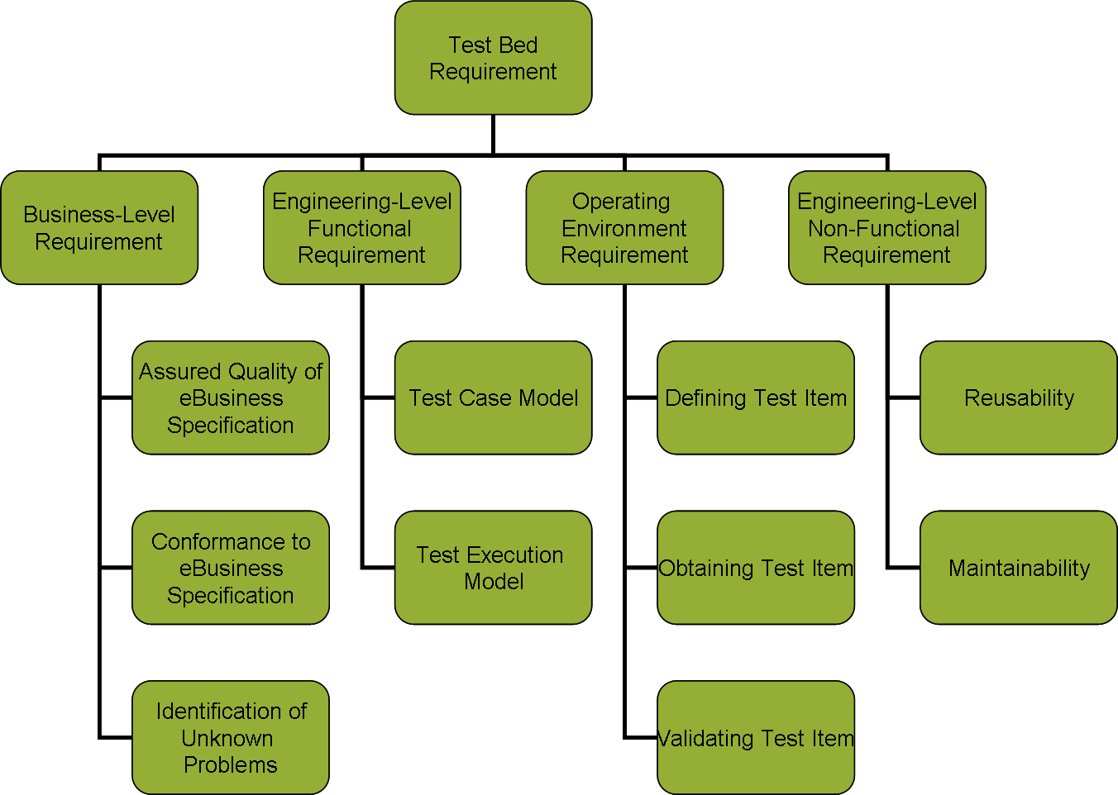

Figure 1 - Top-level Model of the eBusiness Test Bed Concepts

Figure 1 illustrates our initial top-level model of the test bed concepts and the first level refinement of these concepts. Our top concept, Test Bed Requirement, is refined into the four basic categories of expressions found in the test bed use cases, as described in the previous section. (Note that we cannot show all the levels of the model here, due to space limitation.)
The first category, Business-Level Requirement, has associated taxonomy that refines abstract business-level requirements into leaf-level, generic business level requirements. Business-level requirements address “What concern to test for” including: Assured Quality of eBusiness Specification, Conformance to eBusiness Specification, and Identification of Unknown Problems. A generic business-level requirement is an atomic expression of business need that does not make sense to be further refined.
For example, the Conformance to eBusiness Specification abstract business-level requirement may be one of Business Process Unit, Business Document Unit, Messaging Unit, or Profile type. Then, each of the first three types is categorized into one or more subclasses of the eBusiness specification that relates the type of function involved. For example, the Business Process Unit will have two categories: Function of Normal Execution and Function of Failed Execution.
Finally, at the leaf level, there are the generic business-level requirements. For example, the Function of Normal Execution requirement contains the generic requirements Message Flow Conformance to Choreography Specification (Choreography), and Interaction and Message Flow Conformance to Role Specification (Roles).
The purpose of the generic business-level requirements is to represent original use case-based business requirements in a well-defined terminology as a basis for further analysis. So, for a given abstract or non-generic (i.e., non-atomic) business-level requirement, the taxonomy provides all potential generic (i.e, atomic) business-level requirements that may be used to express the original requirement. Any number of generic business-level requirements may be selected to express original use-case based business requirements.
The second category, Engineering-Level Functional Requirement, has an associated taxonomy that refines high-level engineering-level functional requirements (i.e., Test Case Model and Test Execution Model) into refined, atomic (or generic) functional requirements. The purpose of this taxonomy is two-fold. First, it expresses use case-based engineering-level functional requirements within a well-defined structure. Second, it allows expression of functional capabilities of existing test beds within a well defined structure. This will enable use of the taxonomy and the resulting terminology to perform the gap analysis.
The third category, Operating Environment Requirement, has an associated taxonomy that introduces in a useful manner the operating environment categories, such as defining, obtaining, and validating test items, which are the basis for actually performing testing. The requirements are refined to the level that allows for expression of and differentiation among generic (atomic) business level requirements. In other words, essentially different business level requirements need to be naturally differentiated by two distinct combinations of Operating Environment Requirements.
The fourth category, Engineering-Level Non-Functional Requirement, has an associated taxonomy that identifies two top-level categories (Reusability and Maintainability) and their additional sub-categories (Modularity and Plug-and-Play Capability; and Extensibility and Robustness; respectfully).

Gap Analysis
The formulation of both the shared conceptualization (terminology) and the target space of analysis is (1) driven by feasibility analysis concerns; (2) intended to drive the gap analysis; and (3) subject to iteration as new use cases, requirements, and testing capabilities are introduced in the analysis framework. The possible outcomes of the gap analysis may be that the existing testing facilities (1) meet, (2) do not meet, or (3) partially meet use case requirements under the given assumptions.

Risk Analysis
The preliminary risk and cost analysis follows the gap analysis. The risk analysis necessarily is qualitative in nature and considers a new, possibly hypothetical, collection of use cases containing new requirements expressions. For these new requirements, the conceptualization of the GITB is evaluated for the new refinements that may be necessary. The analysis should show whether re-formulating the original expressions in the conceptual space affect the gap analysis results. Further, assessment is performed of the importance of the additional requirements within the space of analysis and what may be the risk from not including the requirements in the first place.

Feasibility Analysis for Global Interoperability Test Bed
In this section, we apply the above methodology to perform feasibility analysis for GITB.
Table 1 shows the original use case-based business-level requirements (with exception of the Assured Quality of eBusiness Specification category) and their classification using the Taxonomy of Business-level Requirements, as described earlier. One should visualize the table’s first two columns (the Abstract and Generic Business Level Requirements) to exactly correspond to the taxonomy. The three right-most columns in the table show the actual requirements for the three use cases: eHealth, long-distance automotive supply chain (MOSS), and eProcurement, respectively.
Few observations are of interest. First, not all possible generic business-level requirements (as represented and anticipated in the taxonomy) are present in the use cases. This is normal, as the use cases may not include all possible test requirements for various reasons. Next, most business requirements in the MOSS use case are focused on the Conformance to eBusiness Specification that is of Business Document Unit kind This is in fact the nature of the MOSS use case that focuses on conformance testing of the business documents specified in that particular project. On the other hand, eHealth is equally concerned with all aspects of the eBusiness specification profile: business process, business document, and messaging protocol, as can be seen from equal distribution of the requirements across those top-level abstract business requirements.
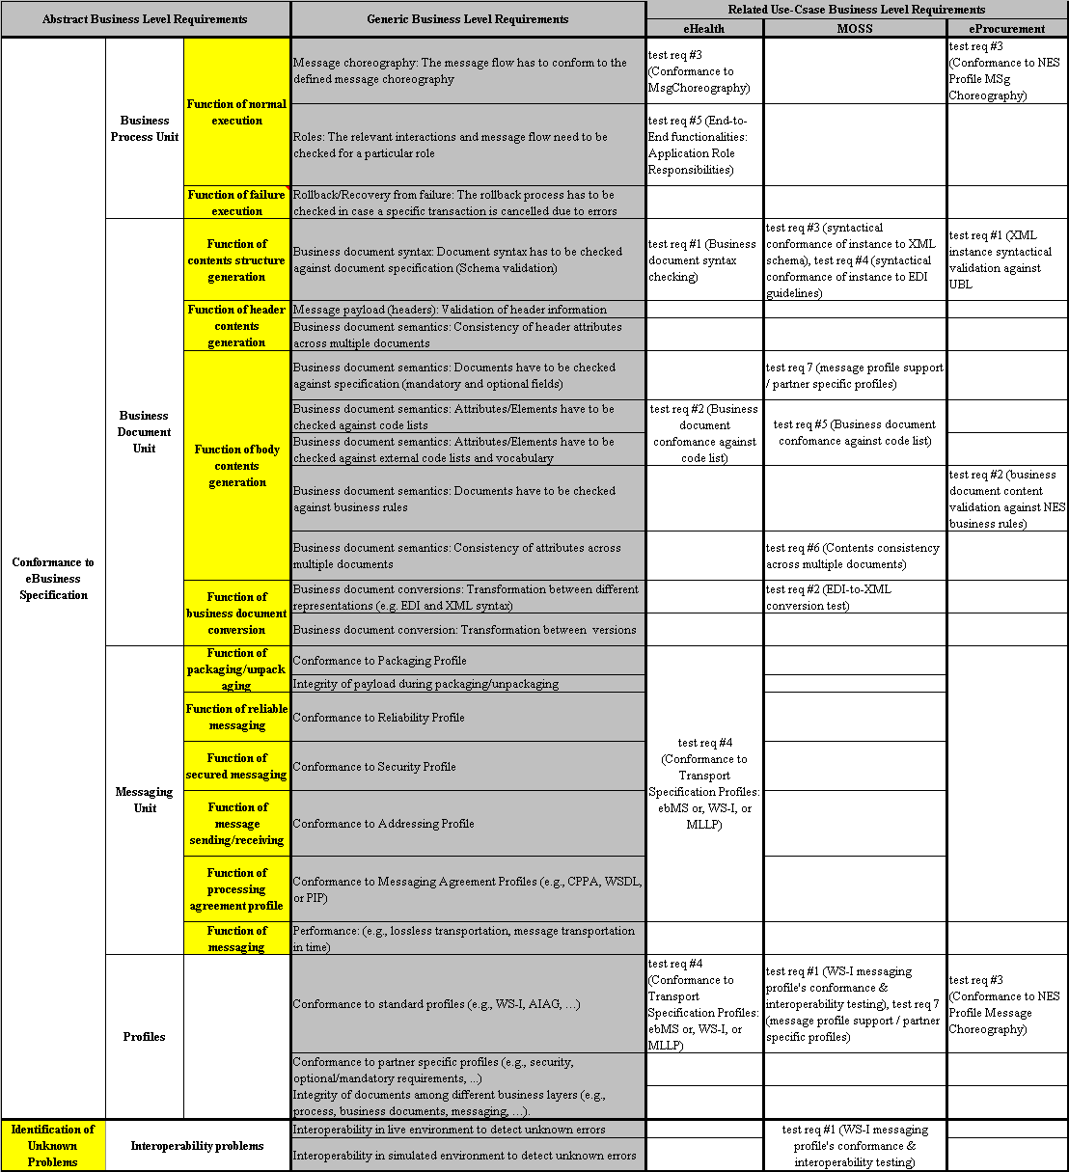

Table 1 – Use case-based business-level requirements and their classification

Table 2 shows the use case-based engineering-level functional requirements and their classification using the Taxonomy of Engineering-level Functional Requirements. The three right-most columns in the table show the actual functional requirements for the three use cases: eHealth, MOSS, and eProcurement, respectively.
The MOSS functional requirements are more numerous than the other two use cases. This is because we have derived the MOSS functional requirements from high-level business requirements that gave rise to virtually all functional requirements, according to our knowledge structures that map the business to functional requirements. On the other hand, the functional requirements for the eHealth and eProcurement are more precise and less numerous, as a consequence of mature understanding of the domains and testing needs.

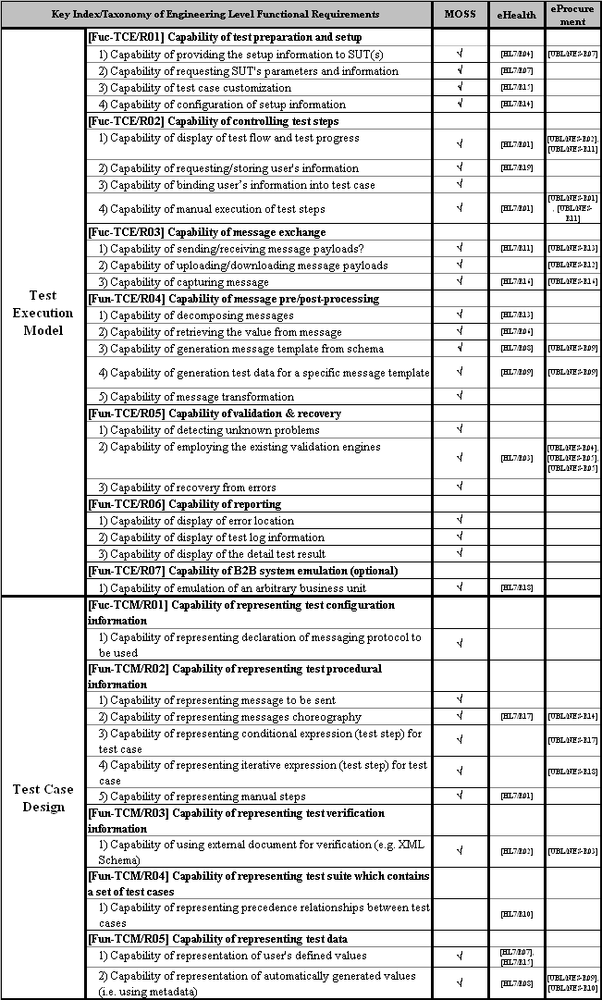

Table 2 – Use case-based functional requirements and their classification
Table 3 shows summary of the existing testing capabilities, based on the previous test bed and test framework analysis, categorized with Taxonomy of Functional Requirements. In addition, the table shows summary results of the gap analysis between the required functional capabilities and the existing testing capabilities. To address non-functional considerations that were given for each functional testing capability, table uses grey encoding to summarize the levels of such non-functional consideration for each testing capability: Dark fill indicates that the non-functional consideration was completely addressed; Light fill indicates that the non-functional consideration was partially addressed; No fill (transparent) indicates that the non-functional consideration was not addressed at all.
For example, Capability of Manual Execution of Test Steps is required by all three use cases and provided by NIST AIMT, TestBATN, and TTCN-3 as shown in Table 3. In case of this capability, we require two non-functional requirements: modularity and extensibility (as determined in the knowledge-based structure of non-functional requirements). Only TestBATN test framework, however, satisfies both non-functional requirements for this capability (as shown by the dark fill of the cell).

Results
The following are some of the more important findings from the previous analysis:
- Virtually all required capabilities have been addressed in one or more test bed or testing frameworks to provide existing testing capabilities
- A significant, but not complete, part of the existing capabilities have been given a high level consideration. Specifically, from the top of the Test Execution Model in Table 3, one can see that TestBATN has addressed many essential non-functional concerns for this part of functional requirements. On the other hand, from the Test Case Model part of Table 3, one can see that TTCN-3 has addressed many essential non-functional concerns for Test Case Modeling aspect. However, by looking at the middle of Table 3 (corresponding to the bottom part of the Test Execution Model), we see that most of the non-functional concerns for this part of the Test Execution Model have not been addressed.
- Additional concerns need to be taken into account in order for any existing capability to be reused in a GITB. First, if the test component does not expose the target capability, it cannot be reused. Next, a specific functional capability may have a relationship with other test case model and test case execution capabilities. For example, a test execution capability depends on the particular test model capability. Also, before considering reusability of test components, we have to agree upon GITB standard interface of each test components. Finally, each test bed has been developed based on a different programming language and operating environments, which is likely to prevent existing testing capabilities to be re-used.
These issues will be addressed within the Architecture Development phase of the project.

Business Case
While e-business specifications are implemented and adopted globally and interoperability is a major requirement to be observed in e-business standardization deliverables, it is still cumbersome to achieve and demonstrate full compliance with the specified standards. This is due to a number of facts: (1) e-Business interoperability typically requires that a full set of standards – from open internet and Web Services standards to industry-level specifications and e-business frameworks – are implemented; and (2) there are only limited and scattered testing facilities. The proposed Global Interoperability Test Bed is meant to accommodate a full set of standards (e.g., within a target profile) within various testing situation and requirements.
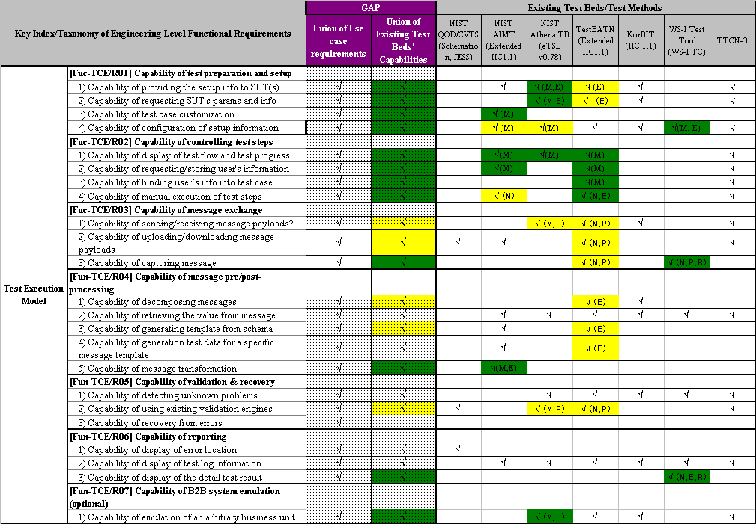
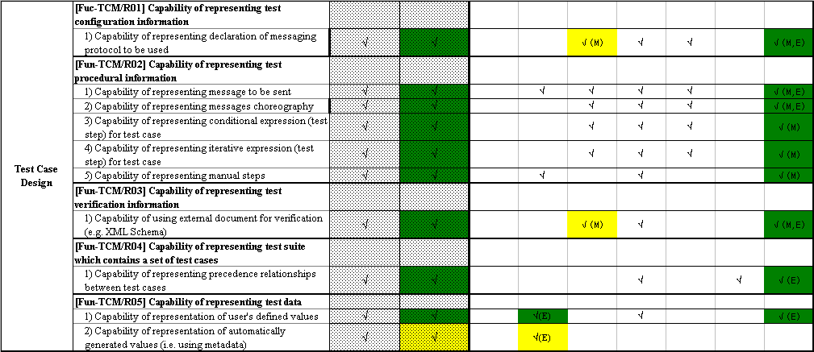

Table 3 – Existing testing capabilities and Gap Analysis

Conclusions and Future Work
There is an increasing need to facilitate interoperability and develop testing methodologies for e-business scenarios, which requires global collaboration among the institution form the representative regions. The Global Interoperability Test Bed project’s long-term objective is to develop a comprehensive and global e-business interoperability test bed. The current feasibility analysis phase provides a gap analysis and preliminary risk analysis. In the next two phases, the team will first analyze alternative architectural approaches to GITB and, then, prototype and demonstrate the GITB concept on select industrial use cases.

Acknowledgements
This work has been done in collaboration with the EU-funded CEN activity. We greatefully acknowledge support of Mr. John Ketchell and Ms. Barbara Gatti.

