iSURF Semantic Interoperability Service Utility for Collaborative Planning, Forecasting and Replenishment
Yildiray KABAK¹, Asuman DOGAC², Cagdas Ocalan¹, Server Cimen², Gokce B. Laleci¹
¹Software Research, Development and Consultancy Ltd.,
METU-KOSGEB Tekmer, Ankara, 06531, Turkey
Tel: +90 312 2102076, Fax: + 90 312 2105572, (yildiray, cagdas, gokce)@srdc.com.tr
²Dept. of Computer Engineering, Software Research & Development Center
Middle East Technical University, İnönü Bulvari, Ankara, 06531, Turkey
Tel: +90 312 2405598, Fax: + 90 312 2101259, (asuman, server)@srdc.metu.edu.tr
Abstract: One of the key challenges in supply chain collaboration is to improve the efficiency and effectiveness of the planning process to handle rapidly changing customer demands. For this purpose, supply chain partners need to exchange planning information in a timely and seamless manner. When establishing a new collaboration, the partners usually face with interoperability problems, because it is often the case that they conform to different electronic document standards for collaborative planning. Regarding electronic business document interoperability, the leading effort for creating a standard semantic basis to solve electronic business document interoperability problem came from the UN/CEFACT (United Nations Centre for Trade Facilitation and Electronic Business) Core Components Technical Specification (CCTS) through a document modelling methodology. After this initiative, most of the electronic document standards implemented or adapted the CCTS methodology. However, being CCTS conformant does not necessarily mean that a CCTS based document standard is interoperable with other CCTS based document standards. In order to address these problems, we develop a semantic Interoperability Services Utility (ISU) for the interoperability of CCTS based electronic document standards for the exchange of supply chain planning information. This work is supported by the European Commission through ICT- 213031-iSURF project.

Introduction
In order to optimize the overall profitability, the companies need to plan their future orders with their partners collaboratively. This requires collaborative planning within a supply chain and exchange of planning data. Up to now there have been a number of efforts to provide a common medium for collaborative planning and exchange of required planning data among the partners in the supply chain. Collaborative Planning, Forecast and Replenishment (CPFR©) is one of the most prominent initiatives on collaborative planning, which has been initiated by VICS (Voluntary Inter-industry Commerce Standard) [12]. The CPFR© is a reference model providing a generic framework for the collaborative aspects of planning, forecasting and replenishment processes.
Furthermore, there are various standard initiatives addressing the standardization of communication in exchanging the supply chain planning documents in different domains, such as RosettaNet [11], OAGIS [9], CIDX [1] and GS1 eCom [3]. Hence, when companies involving in more than one supply chain need to exchange this planning information across multiple domains, they face electronic business document interoperability problem. For example, consider the supply chain partners presented in Figure 1, which involves several supply chains. A company may use a single data exchange standard within the scope of a single network. For example, Company A conforms to RosettaNet as a part of RosettaNet community in Figure 1. However, for Company A to be able to communicate with other companies in different networks, which may conform to a different data exchange standard (e.g. OAGIS), there is a need for a flexible interoperability solution. Otherwise, each company has to produce planning and forecasting messages in more than one standard, as Company A does in Figure 1, and it should be noted that this puts a lot of burden on the IT budget of SMEs.
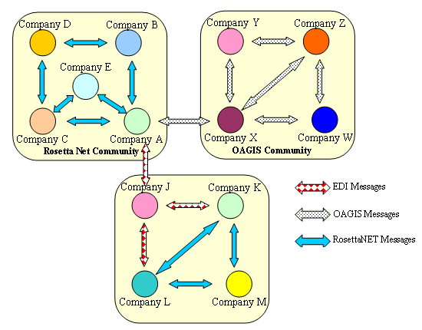
Figure 1Interactions between different CPFR Communities
Considering business document interoperability, the earlier standards have focused on static message/document definitions, which were inflexible to adapt to different contexts, which could be a vertical industry, a country or a specific business process. The leading effort for defining business document semantics came from the UN/CEFACT Core Components Technical Specification (CCTS) [17] in the early 2000s. UN/CEFACT CCTS provides a methodology to identify a set of reusable building blocks, called Core Components to create electronic documents.
CCTS is gaining widespread adoption by both the horizontal and the vertical standard groups. Universal Business Language (UBL) [14] was the first implementation of the CCTS methodology in XML. Some earlier horizontal standards such as Global Standard One (GS1) XML and Open Applications Group Integration Specification (OAGIS) have also taken up CCTS. However, because they use CCTS differently, there is still an interoperability problem among the CCTS based electronic document standards.
In order to address these problems, we describe the Interoperability Service Utility (ISU) developed within the scope of IST-213031: iSURF (An Interoperability Service Utility for Collaborative Supply Chain Planning across Multiple Domains Supported by RFID Devices) project [6]. The ISU provides interoperability between different UN/CEFACT CCTS based document standards for planning and forecasting information by means of ontology reasoning based on both the description logics and the predicate logics.

Methodology
Although the document standards use the UN/CEFACT CCTS, there are considerable differences among them, because they apply the CCTS methodology differently [7]. As a natural consequence of these differences, CCTS based document standards are not interoperable and it still requires experts to discover the correspondences between document artifacts and to map them. Furthermore, the current accepted practice of storing the document artifacts in spreadsheets does not facilitate to develop automated semantic interoperability support tools. In order to help with the interoperability of the document artifacts, we explicate the CCTS based business document semantics. By “explicating”, we mean to define their semantic properties through a formal, machine processable language as an ontology and the Web Ontology Language (OWL) [13] is used for this purpose. The semantics is explicated at two levels: At the first level, an upper ontology describing the CCTS document content model is specified. Furthermore, at this level, the upper ontologies for the prominent CCTS based standards, namely, GS1 XML, OAGIS and UBL are also developed. At the next level, the semantics of the document schemas in each standard are described through “document schema ontologies”, which are based on their corresponding upper ontologies. The difference between the “document schema ontology” and the “upper ontology” is that the upper ontology describes the generic entities in a document content model, whereas document schema ontologies describe the actual document artifacts as the subclasses of the classes in the upper ontology.
When these ontologies are harmonized using a Description Logics (DL) reasoner, the automatically computed inferred ontology reveals the implicit equivalences and subsumption relationships between the document artifacts in different standards. In other words, the newly identified ontological relationships shows the relations among the semantically similar document artifacts, which are in different standards. It should be noted that currently the common practice to find these relationships between the artifacts of different standards is manual. However, in iSURF ISU these relationships are generated automatically.
Sometimes, the harmonized ontology is effective only to discover equivalence of both semantically and structurally similar document artifacts. In other words, the use of description logics only allows finding relations between document artifacts whose semantics and structure are similar. Therefore, for identifying the relations between semantically similar document artifacts, whose structure is different, we provide further heuristics in terms of predicate logic rules. Note that a DL reasoner by itself cannot process predicate logic rules and we resort to a well accepted practice of using a rule engine to execute the predicate logic rules and carry the results back to the DL reasoner. The results involve declaring further class equivalences in the harmonized ontology. Finally, the similarities discovered among the document artifacts are used to automate the mapping process by generating the XSLT rules.

Upper Ontologies
In iSURF ISU Framework, as mentioned previously, at the first level, an upper ontology describing the CCTS document content model is specified. As shown in the upper part of Figure 2, the ontology classes are constructed from the concepts used in CCTS methodology. The most basic concept is Core Components. Core Components are the building blocks for semantically correct and meaningful business documents. In CCTS, a compound document artifact, termed as an Aggregate Core Component (ACC) is composed of either atomic document artifacts, termed as Basic Core Components (BCCs) or by defining associations, termed as Association Core Components (ASCCs) to other compound document artifacts. In other words, a BCC provides a singular element of an ACC (e.g. Street name in Address); an ACC (e.g. Address) is a collection of BCCs and can be part of other ACC via an ASCC property (e.g. OfficialAddress in Party). BCCs are always based on a fixed list of “Core Component Types”, which define the basic information types. When a Core Component is restricted to be used in a specific business context, it becomes a Business Information Entity (BIE). In other words, a Business Information Entity is a Core Component specialized to a specific business context and is given its own unique name. For example, the “Invoice. Tax. Amount” BCC becomes the “Invoice. VAT Tax. Amount” Basic Business Information Entity (BBIE) when the Business Process Context is specialized to “Purchasing” and the Geopolitical Context is set to be “EU”. Similarly, when an Association Core Component is used in a context, it becomes Association Business Information Entity (ASBIE) and Aggregate Core Component becomes Aggregate Business Information Entity (ABIE).
Furthermore, at this level, the upper ontologies for the prominent CCTS based standards, namely, GS1 XML, OAGIS and UBL are also developed, as shown in the lower part of Figure 2. The various equivalence relationships between the classes of the CCTS upper ontology and the CCTS based document standards’ upper ontologies are defined. These relationships are later used to find the similarities among the document artifacts from different document schemas.
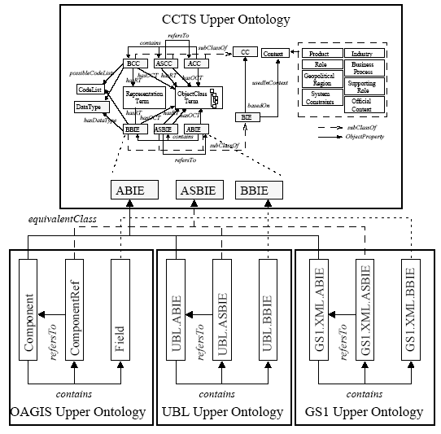
Figure 2 An Overview of the Upper Ontologies

Document Schema Ontologies
Since manually developing an ontology for each document schema is not practical, the generation of ontologies from the document schemas are automated as follows:
- Creating the GS1 XML Document Schema Ontology: GS1 XML defines the Business Information Entities either in “pdf” Business Message Specifications or through the Global Data Dictionary (GDD) [4]. The GDD is a Web accessible registry, where a component is queried by its name. When the “%” character is entered to the search box, all of the BIEs are returned to the user. Through the browser, only the artifact names and the component that contains the artifact is displayed; however, in the HTML source, the type of the artifact (e.g. ABIE, ASBIE or BBIE), the id of the artifact and the id of the ABIE it belongs to are also available. In order to create the OWL ontology corresponding to the GS1 XML artifacts, this HTML code is processed through a software developed and the created classes are inserted.
- Creating the UBL Document Schema Ontology: In UBL, the BIEs are provided in MS Excel spreadsheets. In order to create the UBL Document Schema Ontology: the UBL spreadsheets are first converted to a custom XML format by using XML Map mechanism of MS Excel. Then, the necessary OWL classes of UBL Document Schema Ontology are created from this XML file through a software developed.
- Explicating the Semantics of OAGIS 9.1 Document Schemas: OAGIS provides the XSD schemas of its Components and Fields (e.g. Components.xsd and Fields.xsd) and does not name its components according to ISO 11179 Part 5. Therefore, a special adapter is developed to generate the OAGIS document schema ontology as follows: In OAGIS XSD Schemas, each Component is represented with an element declaration and a corresponding type declaration. When constructing the OAGIS Document Schema ontology, for each element declaration, an ontology class is created.

iSURF ISU Framework
As shown in Figure 3, the ISU Framework is composed of the following components:
- Harmonized Ontology: This ontology contains two types of OWL-DL ontologies: (1) the Upper Ontology and (2) the Document Schema Ontologies. The Upper Ontology describes the CCTS artifacts, such as Business Information Entities and Core Components, as generic classes. The Document Schema Ontologies, on the other hand, describe the BIEs generated by the CCTS based electronic business document standards. There is a Document Schema Ontology for each electronic business document standard. The Document Schema Ontologies are defined conforming to the generic classes defined in the Upper Ontology. The Harmonized Ontology is obtained by running the DL-Reasoner against the Upper Ontology and Document Schema Ontologies.
- DL-Reasoner: A Description Logic (DL) Reasoner is used to identify the equivalence and subsumption relations in the Harmonized Ontology. As the DL reasoner, Racer Pro 1.9.2 Beta is used. The discovered similarities among the document artifacts are then used to generate XSLT definitions for transforming between different electronic business document standards' XML Instances.
- Predicate Logic Rule Engine: In some cases, the Description Logic is not sufficient to find relations between document artifacts. Therefore, in these cases, generic heuristics in the form of Predicate Logic Rules are used. The JESS Rule Engine is used to execute the heuristics to find additional relations among the Document Schema Ontology classes.
- Ontology-PL Facts Wrapper: The document artifacts are represented through OWL classes and properties in the Harmonized Ontology and they are represented as facts in the Predicate Logic Rule Engine. This wrapper converts the OWL definitions to facts definitions which are then asserted to the rule engine. After the rule engine is executed, new relations among the classes are inferred. These new relations are also represented as facts. The wrapper converts the newly obtained fact definitions back to OWL class equivalences to be inserted to the Harmonized Ontology.
- Additional Heuristics: These heuristics are given through the Predicate Logic Rules to identify the relations among the document artifacts which cannot be identified through Description Logic.
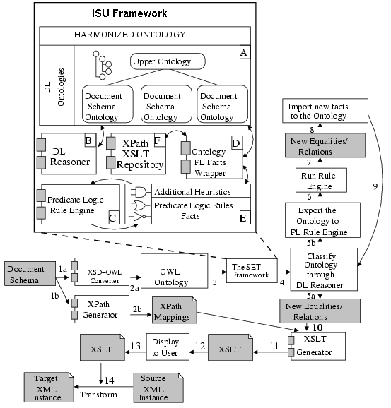
Figure 3 iSURF ISU Framework
Additionally a number of tools are developed to support this framework:
- The XSD-OWL Converter: This component converts a CCTS based document schema into OWL Definition described in this deliverable.
- The XPath Generator Tool: The XPath Generator extracts the correspondences between the XSD Schema elements in the document schemas and the OWL classes in the Document Schema Ontologies through XPath expressions. These expressions are then used to generate the XSLT definitions.
- The XSLT Generator Tool: This component generates the XSLT definitions by using the XPath definitions and the newly computed equivalence/subsumption relations. These XSLT definitions are used in the transformation between two XML Instances conforming to different electronic business document standards.
- Ontology-PL Facts Wrapper as explained above.

This framework is used to transform a source XML instance to a target XML instance. If the document schemas of these instances are already in the Harmonized Ontology, the corresponding XSLT transformations can directly be used. If the source, or the target or both of these document schemas are not yet in the Harmonized Ontology, first they must be inserted through the following procedure as shown in Figure 3: (1a) First the OWL Document Schema Ontology conforming to the specifications described in this deliverable are created from the XSD Document Schemas (2a) by using the XSD-OWL Converter. (1b) In the mean time, the XPath Generator Tool is used to keep track of the correspondences among the XSD elements and OWL classes to generate XPath Mappings (2). (3) Then, the OWL ontologies are inserted to the Harmonized Ontology and (4) the ontologies are classified with the DL Reasoner and the Harmonized Ontology is computed. In this step new equality/subsumption relations are produced (5). At the same time, the OWL definitions are converted to Predicate Logic facts by using the Ontology-PL Facts Wrapper Tool and asserted to the Predicate Logic Rule Engine. (6) After that the rule engine is executed and new relations are identified as facts (7). (8) These facts are converted to OWL Definitions through Ontology-PL Facts Wrapper and (9) the newly generated OWL Definitions are appended to the Harmonized Ontology, and the DL-Reasoner is executed again to compute new equality/subsumption relations. The steps from 5 to 9 are executed repeatedly until the Harmonized Ontology reaches a certain maturity level. (10) The equality/subsumption definitions and the XPath Mappings are input to XSLT Generator to produce XSLT Definitions automatically (11). At this point (12) the XSLT Definitions are displayed to the user for further editing (13). Finally, (14) the XSLTs are used to transform to XML Instances conforming to different standards.

Implementation Status and Performance of the System
We have implemented the system and generate mappings between GS1 XML Plan documents [5] and UBL CPFR© [15] documents. In the implementation, the following ten document types are considered: Event, Exception Criteria, Exception Notification, Forecast, Forecast Revision, Performance History, Product Activity, Retail Event, Trade Item Information Request and Trade Item Location Profile. As a result, XSLT documents [18] are generated by following the approach described in this paper. On GS1 XML side, in these documents, there are 42 ABIEs and 75 BBIEs as a total. Our methodology is able to find the corresponding UBL ABIE of 37 GS1 XML ABIEs and the corresponding UBL BBIE of 67 GS1 XML BBIEs. In other words, the success rate for ABIEs is 88.10 % and for BBIEs it is 89.33 %.
Another issue related with performance is the computational complexity of the reasoning process involved. The current version of the Harmonized Ontology contains the ontological representations of:
• All of the CCs and BIEs in UN/CEFACT’s Core Component Library 07B [16].
• All of the BIEs in the common library of UBL 2.0.
• All of the OAGIS 9.1 Common Components and Fields.
• All of the elements in the common library of GS1 XML.
There are about 4758 Named OWL Classes and 16122 Restriction Definitions in the current version of the Harmonized Ontology. On a PC with 2GB RAM, the Racer Pro 1.9.2 Beta reasoner takes about 120 seconds to compute the Harmonized Ontology. Considering that the Harmonized Ontology will be re-computed only when a new document schema or a new CCTS based upper document ontology is introduced to the system, this performance is quite acceptable.

Business Benefits and Conclusions
CPFR© initiative has started to be taken up in 2001 especially in North America by early adapters through several pilot projects. An example to these is the two phase pilot between Intel Corporation and Shinko initiated to automate the forecast-to-cash procurement phase through RosettaNet standards [8]. Another successful collaborative planning initiative is coming from a European chipmaker, STMicroelectronics based on RosettaNet standards. Furthermore, there are also pilot applications for collaborative planning by the following European Companies: Condis, Delhaize, Elgeka, Eqos, Heinz, Hellas Spar Veropoulos, Henkel, JDA, Johnson &Johnson, Ketjuetu, Kimberley-Clark, Kraft, Marks & Spencer, Masterfoods, Nestlé, ONIA-NET, Procter & Gamble, SCA, Superdrug, Syncra [2].
As these pilot projects demonstrate, pioneering companies are achieving improvements in their internal workflows through the adoption of Collaborative Planning mechanisms. However, because of the interoperability problems, collaborative forecasting remains in the early adoption stage for the SMEs. iSURF’s ISU will foster the participation of the SMEs to collaborative planning activities.
In this paper, we describe the iSURF Interoperability Service Utility (ISU), its underlying theory, technology and its implementation. In the iSURF Architecture, the ISU is used to translate CPFR messages conforming to different electronic document standards. For this purpose, we developed XSLT documents that deals with this translation and that are generated semi-automatically as described in this paper. It should be noted that the methodology is generic (i.e. not specific to a specific domain). It is applicable to any UN/CEFACT CCTS based document standards. Therefore, we have also initiated a standardization effort and have formed the OASIS Semantic Support for Electronic Business Document Interoperability (SET) Technical Committee [10] in order to specifying semantic mechanisms for interoperability among Core Component based electronic business document standards. We provided our results in the iSURF ISU as a contribution to the OASIS SET TC and submitted them for standardization.

References
- CIDX: Chemical Industry Data Exchange, http://www.cidx.org
- “European CPFR Insights” prepared by Accenture http://www.ecrnet.org/04-publications/blue_books/pub_2002_cpfr_european_insights.pdf
- GS1 eCOM, http://www.gs1.org/productssolutions/ecom/
- GS1 Global Data Dictionary http://gdd.gs1.org/
- GS1 XML Plan Documents, http://www.gs1.org/services/gsmp/kc/ecom/xml/plan grid.html
- iSURF Project: http://www.srdc.com.tr/isurf/
- Kabak Y., Dogac A. “A Survey and Analysis of Electronic Business Document Standards”. Accepted fpr publication in ACM Computing Surveys.
- http://harvardbusinessonline.hbsp.harvard.edu/relay.jhtml?name=itemdetail&id=GS36&referral=9026
- OAGIS, http://www.oagi.org/dnn/Default.aspx?alias=www.oagi.org/dnn/oagi
- OASIS Semantic Support for Electronic Business Document Interoperability (SET) Technical Committee, http://www.oasis-open.org/committees/tc home.php?wg abbrev=set
- RosettaNet, http://www.rosettanet.org
- VICS, http://www.vics.org/
- Web Ontology Language. http://www.w3.org/2004/OWL/
- UBL: Universal Business Language, http://www.oasis-open.org/committees/ubl/
- UBL CPFR Documents, http://www.oasis-open.org/committees/download.php/28979/UBLforCPFR.zip
- UN/CEFACT Core Components Library http://www.unece.org/cefact/codesfortrade/unccl/CCL07B.xls
- UN/CEFACT Core Components Technical Specification, http://www.unece.org/cefact/ebxml/CCTS_V2-01_Final.pdf
- XSLT document for GS1 XML – UBL CPFR documents, http://www.srdc.com.tr/isurf/documents/Mappings.rar

The research leading to these results has received funding from the European Community's Seventh Framework Programme (FP7/2007-2013) under grant agreement n° 213031

