A Service Oriented Collaborative Supply Chain Planning Environment
Gokce B. LALECI¹, Asuman DOGAC², Mehmet OLDUZ¹, Mustafa YUKSEL¹, Samia DRISSI³ and Alessandro CANEPA⁴
¹Software Research, Development and Consultancy Ltd.,
METU-KOSGEB Tekmer, Ankara, 06531, Turkey
Tel: +90 312 2102076, Fax: + 90 312 2105572, (gokce,mehmet,mustafa)@srdc.com.tr
²Dept. of Computer Engineering, Middle East Technical University, İnönü Bulvari, Ankara, 06531, Turkey
Tel: +90 312 2405598, Fax: + 90 312 2101259, asuman@metu.edu.tr
³ Fraunhofer-Gesellschaft Institute Manufacturing Engineering and Automation,
Nobelstrasse, 12, 70569, Stuttgart, Germany
Tel: +49-711-9701186, Fax: +49-711-9701507, Samia.Drissi@ipa.fraunhofer.de
⁴Fratelli PIACENZA S.p.A.,
Regione Cisi, 13814 Pollone - Italy,
Tel: +390156191237, alessandro.canepa@PIACENZA1733.it
Abstract: One of the key challenges in supply chain collaboration is to improve the efficiency and effectiveness of the supply chain planning process to handle rapidly changing customer demand. Trading partners usually have different competencies based on their business strategies and investments. They have varying sources of information and also dissimilar views of the marketplace. The distributed intelligence of multiple trading partners needs to be collaboratively exploited in the planning and fulfilment of customer demand in the supply chain so as to enhance supply chain responsiveness. Although CPFR guidelines exist, the deployment of CPFR processes is too cumbersome and labour intensive especially for SMEs. iSURF Project provides a Service Oriented Supply Chain Planning Environment to European SMEs so that they can easily adopt collaborative planning practices.

Introduction
The European companies, especially the SMEs, should be more agile, self-sustainable and responsive to the changes in the supply chain to be able to survive in the demanding economy. The supply chain partners can better adjust to the changing demands when a collective intelligence can be created within the supply chain through collaborative planning.
The CPFR® [1] guidelines present collaborative business practices enabling the trading partners to have visibility into one another’s critical demand, the order forecasts and the promotional forecasts through a systematic process of shared brand and category plans, exception identification and resolution. The main idea behind performing the planning and the forecasting jointly comes from the fact that trading partners have different competencies based on their strategies and investments. Also, the trading partners have different sources of information and different views of the market. By sharing planning and forecasting data, the intelligence of multiple trading partners can be combined in the planning and fulfilment of customer demand. The main objective of CPFR® is to increase the accuracy of demand forecasts and replenishment plans necessary to lower inventories across the supply chain and attain high service levels of the right products at the right locations [2]. As a result, trading partners would benefit from increased sales.
Promising a significant amount of improvement on the efficiency of the supply chain management, CPFR® Guidelines have attracted a considerable attention from the industry. Voluntary Interindustry Commerce Solutions (VICS) [3] reported that since the publication of CPFR® guidelines in 1998, over 300 companies have implemented the process. Numerous case studies of CPFR® projects document in-stock percentage improvements of from 2-8% for products in stores, accompanied by inventory reductions of 10-40% across the supply chain [1].
However, in successful CPFR® pilot applications, it has been reported that the definition and deployment of CPFR® processes within a supply chain consortium is too costly and labour intensive [4]. Although CPFR® provides guidelines; there is no machine processable process templates defined. Also, CPFR® does not mandate any technology to implement the CPFR® approach, as a result the consortiums that have agreed to collaborate based on CPFR® guidelines need to implement their own strategy. This also hampers the scale of CPFR® processes: consider, for example, a company that needs to communicate with two different supply chain consortiums: most probably separate processes will be implemented for each of the CPFR® processes needed.

Objectives
CPFR® envisions providing significant effects on the supply chain; however the effects will be dramatic only when it is completely integrated with the demand plan of an enterprise, in which the production cycle is synchronized with CPFR order cycle. Considering that supply chain partners may get involved in more than one collaborative scheduling and planning processes, the decision mechanisms to be used covering all the planning criteria in each CPFR® network becomes much more complex. Hence there is a need for tools and methodologies to design this inter-enterprise collaboration process across multiple domains. For addressing these problems and accelerating the adoption and the usage of the CPFR® especially by European SMEs, within the scope of iSURF project [5], a Service Oriented Collaborative Supply Chain Planning Process Definition and Execution Environment is developed [6]. This architecture provides machine processable building blocks of Collaborative Supply Chain Planning (CSCP) Process in ebXML Business Process Specification (ebBP) [7]. It also enables the generation of completely customized planning business process definitions graphically by using these building blocks.
The collaborative planning process should work fully integrated with the already existing enterprise legacy applications of the companies. This is achieved through Legacy Adapters to enable iSURF Framework to exchange messages with the underlying enterprise Legacy Applications over the Enterprise Service Bus. In order to achieve this, the features expected from Legacy Applications are wrapped as Web Services. In other words Legacy Applications, which do not support the Service Oriented Architectural concepts, are enabled to call the Web Services provided by iSURF, as well as delivering internal data to be processed by iSURF Web Services.
Finally iSURF CSCP environment facilitates the binding of these legacy services to planning process definition and then creation of an executable business process, as WS-BPEL [8] definitions.
In the following sections, we introduce the technical architecture of iSURF CSCP Environment and Legacy Adapters. In Section 4, we describe how we aim to enhance an existing supply chain collaboration process through iSURF components enabling collaborative planning.

Methodology and Technology Description

iSURF Collaborative Supply Chain Planning Environment
As the first step in providing a Service Oriented Collaborative Supply Chain Planning (CSCP) environment, the building blocks of collaborative supply chain planning process have been defined as machine processable binary collaboration patterns. For this purpose, first, the Collaborative Planning, Forecasting, and Replenishment (CPFR®) guidelines for the planning process between the retailer and the manufacturer have been examined, and with the help of the end users of the iSURF Project, we have identified the building blocks, as binary collaboration definitions. Each Binary Collaboration Definition involves the exchange of a number of Planning Documents. These binary collaboration definitions are the template guidelines for the SMEs to build their own collaboration processes based on their supply chain topology and requirements. These building blocks are represented through a machine processable business process specification language, namely the, OASIS ebXML Business Process Specification Schema (ebBP) [7].

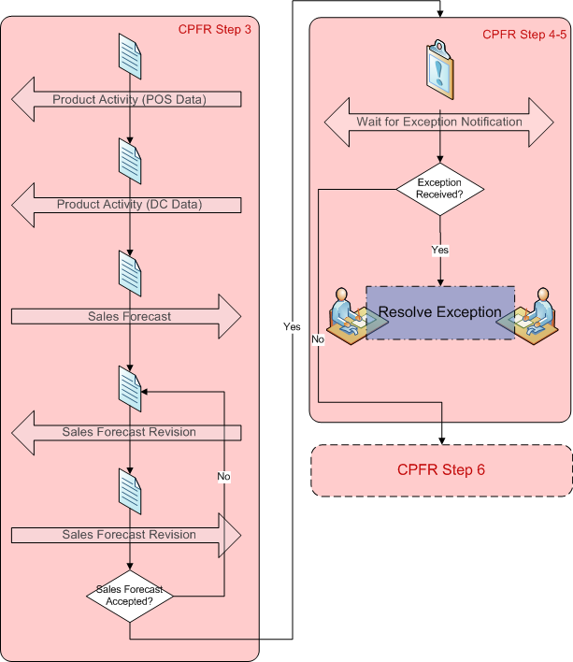
For example in Figure 1, the “Sales Forecast Generation” step in CPFR® process requires the Buyer to send “Product Activity” data to the Seller; in response, the Seller creates a “Sales Forecast” document and sends this back to the Buyer. To represent such business collaborations as CSCP Process templates in ebBP, the following actions are taken:
Figure 1 Example CPFR Building Block
- “Roles” are defined such as “Retailer Ltd” and “Manufacturer Ltd”
- For each Planning Document that is being exchanged in CPFR® process (such as Sales Forecast) a “Business Document” definition in ebBP is created.
- For each planning document exchange between buyer and seller, a “Business Transaction” definition in eBBP is created. ebBP proposes eight different Business Transaction types. In the iSURF Project, we use “Notification” type, which represents a formal exchange between parties; in CPFR there is no need for request-response type of communication.
- “Business Collaboration” definitions are created in ebBP to group a set of Business Activities executing Business Transactions between the business partners or the collaborating parties. Here, the ordering and the transitions between Business Transactions are specified. For example a “Business Collaboration” definition is defined for “Sales Forecast Generation” Step.
- “Transition”s are used to represent direct transitions between Business Activities, and “Decision” definitions are used to define conditional or optional transitions.
- “Business Signal”s are used to represent “Receipt Acknowledgement and/or an Acceptance Acknowledgement” messages.
Once the CPFR process is modelled as machine processable building blocks, the CSCP Process Design Tool can load these templates, so that the supply chain partners can graphically visualize and update the process as they wish.

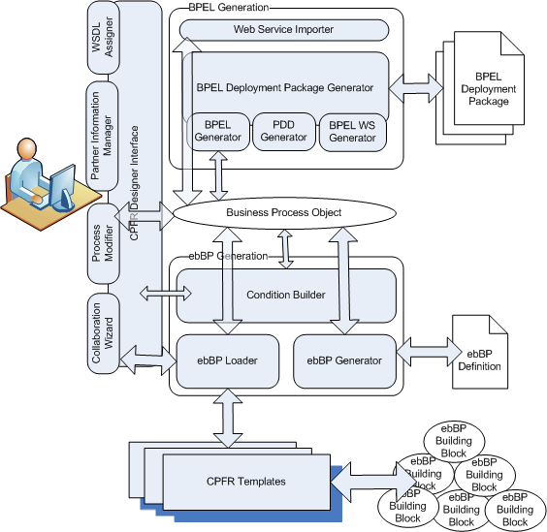
Figure 2 iSURF CSCP Process Definition Platform
The architecture of iSURF CSCP Process Definition Platform is depicted in Figure 2. The users first administer their company information through the “Partner Information Manager”. This includes the company profile information, the contact people and the products. Then they select designing a new Collaborative Supply Chain Planning Process. CPFR® proposes different scenarios such as “Buyer-Managed” or “Seller-Managed”, where either Buyer or Seller creates the forecasts on behalf of the other party. Through “Collaboration Wizard”, the partners are enabled to select the scenario that will be used and the product that is in the scope of CSCP Process. The corresponding Collaborative Supply Chain Planning Process template is loaded from the CPFR® Templates (composed of ebBP building blocks) by “ebBP Loader” and converted to the “Business Process Objects”. “Business Process Objects” is an “internal in memory process model” of the iSURF CSCP Process Definition Platform. Then the “Designer Interface” displays the graphical view of the CSCP Process as presented in Figure 3. The users then add/remove/modify the Message Exchange States (MES) and the message flow. The new conditions might be built by “Condition Builder”. Once the users finalize the customizing process, ebBP definition of the process is generated and saved.
Through these steps, a choreographic definition of the customized business has been generated. To generate the executable WS-BPEL [8] business, the users advance to the WS-BPEL Design phase after finalizing the visual process definition. In this step, the users load the Web services for their legacy systems and associate each of the actions on the message exchange points with an operation from the related Web service. Once this process is also completed, the “WS-BPEL Deployment Package” can be generated by the system. The package includes the WS-BPEL (.bpel) files, the Process Deployment Descriptor files for the BPEL engine and the WSDL files (describing the operations of the BPEL processes) for each of the collaborating partners. This deployment package can be deployed to an Apache ODE (Orchestration Director Engine) [9], an open source BPEL engine. The supply chain partners then can initiate the collaborative supply chain planning process from their existing enterprise planning systems.

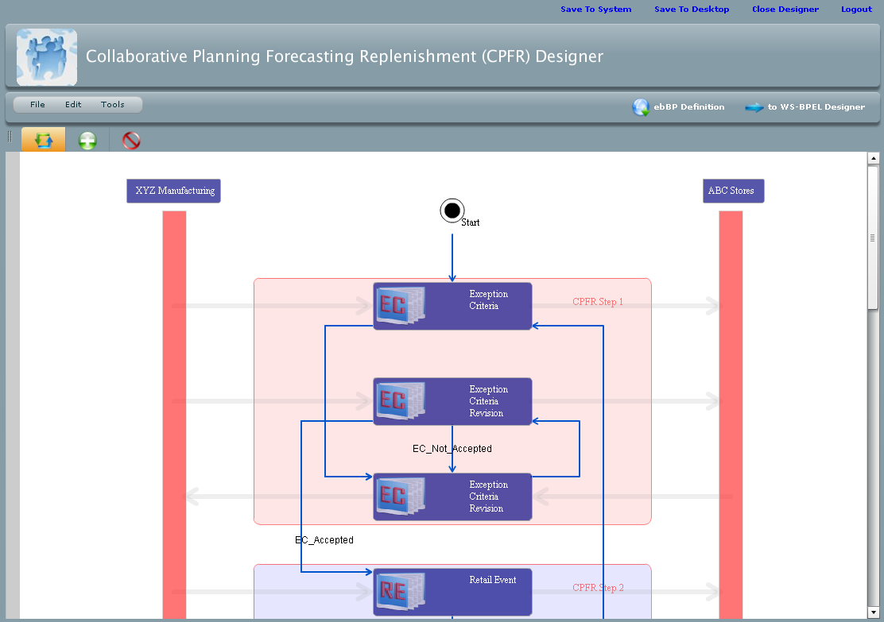
Figure 3 CSCP Process Designer Interface

Legacy Adapters to Communicate with Enterprise Planning Applications
An important component of the iSURF project is the open interface to legacy systems that enables the reliable communication with different software systems and applications. With the support of the Legacy Adapters, different legacy applications, devices or system are then able to communicate in a common way to the iSURF framework and call the related Web Services such as those provided by the CSCP.
There are some research studies and available products on the market focusing on this issue by providing a whole suite for integration. These products usually use one of the following technologies such as Web services, Java2 Connector Architecture (JCA), Java Message Service (JMS), COM Interface, .NET. Because iSURF is a platform independent system, we investigate only Web services, JMS and JCA. After a detailed comparison of the three investigated technologies, the decision was to implement a Web Service Interface for loose coupling of components and optionally a JMS interface for tight coupling that relies on fast data exchange. This approach aims at handling the communication link supported by the backend system, by wrapping related features as Web Services, and thus providing a SOAP enabled access layer to the Enterprise Service Bus.
Based on this, developing the Legacy Adapters consists of the wrapping of needed functionality of the legacy applications, and also the transmission of messages and data between those Web Services and the available iSURF-Services via the Enterprise Service Bus; by ensuring the correctness and the privacy of the messages. From this point of view we identify the following requirements:
- As illustrated in Figure 4, first some features inside legacy applications have to be wrapped as Web Services, as being responsible for handling incoming and outgoing data that are relevant for iSURF. At this point it is worth mentioning that this procedure cannot be achieved in a generic automatic way, since each legacy application has its own specific integration layer. For this reason, this task is achieved in extensive cooperation with the end-users.

Figure 4 Wrapping Legacy Applications through Web Services
- Once a legacy application is able to call a Web Service inside iSURF, an appropriate Binding Component is responsible for the further processing of the messages through the Enterprise Service Bus, as shown by Figure 5.

Figure 5 Binding Components

- For outgoing messages, a Routing Mechanism will be available on Enterprise Service Bus side, in order to invoke the Receive Methods on the legacy applications, as shown by Figure 6.

Figure 6 Web Service Recieve Invoker

- On legacy application level appropriate Receive-Method will be provided, in order to enable the consumption of data delivered by iSURF, as shown by Figure 7.

Figure 7 Legacy Application Frontend WSDL

Based on these requirements, the Legacy Adapters are being built on Web Services according to the principles of the Service Oriented Architecture. They shall provide external applications the ability to access and communicate with the Enterprise Service Bus. In turn the Enterprise Service Bus has to dispose of a service enabling the call of external legacy applications. So in order to achieve ingoing communication, Web Services are being implemented and exposed to outside, being a central layer for handling incoming messages. These Web Services are built as POJO components, and identified henceforward as POJO Web Services.
In order to achieve outgoing communication, the Enterprise Service Bus provides a component, providing the ability to call external Web Services and appropriate methods. This component is referred to as a Web Service Receive Invoker (WSRI)-Component. In this respect, the legacy applications are seen as external Services, and have to expose a receive method over WSDL, in order to receive messages.
Figure 8 illustrates the overall architecture of the Legacy Adapters:

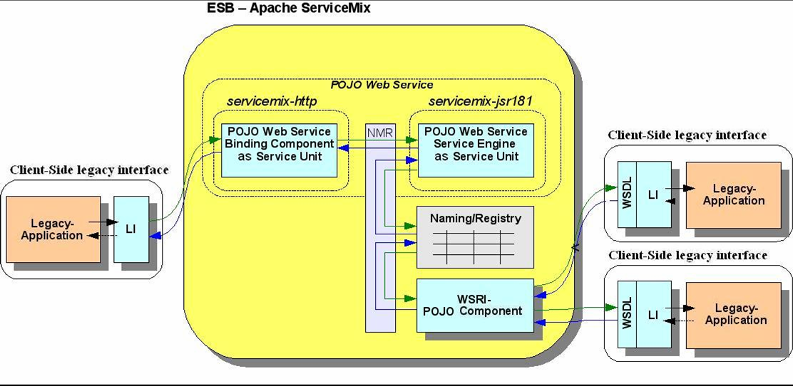
Figure 8 Legacy Adapters Overall Architecture

Business Benefits
The iSURF architecture will be deployed in the premises Fratelli Piacenza S.p.A. [10], a manufacturer of noble fibres fabrics and pure cashmere clothing and accessories, supplier to almost all luxury apparel brands (including Italian ones among which Zegna, Brioni, Canali, Gucci and international ones like Louis Vuitton, Hermès, Escada, Basler, Celine, Chanel) and high end multi brand retailers.
The current production of PIACENZA is purely order based [11]. This is not a big problem for winter season preparation phase, since the orders are collected well before. However this is not the case for the “Re-order-Gift” Season which starts in October and end in December and the products are needed to be delivered immediately to retailers. The delivery of the replenishment orders should be immediate, hence the production of these possible orders should be initiated well before (around April) based on forecasts. iSURF CPFR® based Collaborative Supply Chain Planning Process will enable the partners to more effectively create a joint forecast based on historical and real time data. The partners will be able to share purchase conditions, Trade Item location Profiles (Frozen Period Days, Minimum Inventory Levels, Order Quantity minimum and maximums etc.), Retail Events, Historical Point of Sales Data, and Distribution Center Withdrawals, and will be able to set common Exception criteria so that forecast exceptions can be caught and addressed in a timely fashion. The sales and order forecasts can be shared and agreed upon. After the Winter Season Delivery is started to be fulfilled in the beginning of June, the real time Point of Sales data will also be shared, which will help the parties to see the variances between statistical forecasts and actual buying patterns.
In addition to this, PIACENZA is outsourcing some of the tasks in the production phase to some sub-suppliers. The CSCP process will also enable collaborative planning between PIACENZA and its sub-suppliers. Based on the order forecast that has been agreed between PIACENZA and its Retailers, PIACENZA will be able to share this forecast with its sub-suppliers so that they can arrange their production environments, reserve the correct number of machines for the batch of tasks that are expected to be received from PIACENZA. In the production phase, continuous communication between PIACENZA and its sub-suppliers will take place over iSURF CPFR® based Collaborative Supply Chain Planning Process in order to monitor the production process and catch exceptions in a timely fashion.

Conclusions
Collaborative supply chain planning has been addressed between big industry players in well defined restricted business circumstances for continuous business relationships through some selected standard message schemes in some pilot projects. However, SMEs are still far behind in this reform of supply chain planning collaboration due to their small IT budgets. In the iSURF Project, we provide an open source Service Oriented Collaborative Supply Chain Planning Environment, through which the supply chain partners can graphically customize CPFR® templates, and create the executable CSCP Process as WS-BPEL definitions. Through this tool, it is also possible to integrate this collaborative planning process with the underlying enterprise planning applications, functionalities of which are wrapped as Legacy Adapters in terms of Web Services. The source code of iSURF CSCP Environment is available in [12].

References
- Voluntary Interindustry Commerce Standards (VICS), CPFR - An overview, May 2004, http://committees.vics.org/committees/cpfr/CPFR_Overview_US-A4.pdf, last visited on August 2008.
- The Next Wave of Supply Chain Advantage: Collaborative Planning, Forecasting and Replenishment, Industry Directions Inc. and Syncra Systems, April 2000.
- Voluntary Interindustry Commerce Standards, http://www.vics.org/, last visited on August 2008
- European CPFR Insights, http://www.ecrnet.org/04-publications/blue_books/pub_2002_cpfr_european_insights.pdf
- IST 213031-iSURF:An Interoperability Service Utility for Collaborative Supply Chain Planning across Multiple Domains Supported by RFID Devices, http://www.isurfproject.eu/
- Mehmet Olduz, “A Service Oriented Collaborative Supply Chain Planning Process Definition and Execution Platform”, MsC. Thesis, Middle Eact Technical University, Computer Engineering Department, September 2008.
- Dale Moberg and Monica J. Martin, The ebBP (ebXML Business Process Specification Schema), OASIS, April 2006, http://www.oasis-open.org/committees/download.php/17857/ebxmlbp-v2.0.3-WhitePaper-wd-r01-en.pdf, last visited on August 2008
- OASIS Web Services Business Process Execution Language, http://www.oasis-open.org/committees/download.php/14616/wsbpel-specification-draft.htm
- Apache ODE (Orchestration Director Engine), http://ode.apache.org/
- PIACENZA Cashmere, http://www.PIACENZA1733.it/
- Dogac A., Laleci G. B., Okcan A., Olduz M., Sesana M., Canepa A., iSURF: An Interoperability Service Utility for Collaborative Supply Chain Planning across Multiple Domains, in the Proc. of the eChallanges Conference, Stockholm, October 2008, pp. 948-955.
- http://sourceforge.net/projects/isurf

The research leading to these results has received funding from the European Community's Seventh Framework Programme (FP7/2007-2013) under grant agreement n° 213031

